Baker Rooming Polices Review
Research has shown that the assignment of rooms in a dorm has a very significant impact on the friendship and culture of a dorm. Because of the impact of rooming, the rooming process is important to maintaining Baker culture. Because of the importance of this process, it is vital that the process operate well and reliably year after year.
The Baker Rooming policies have not been formalized and made available to residents in written form. Because of the lack of information, residents must rely on second hand information about the process from upperclassmen. This causes unnecessary anxiety about the process. At this point in time, Baker Exec has decided to formalize the Baker House Rooming Policies. At the same time as this formalization process is taking place, small tweaks or major revisions may be introduced into the process.
More can be done to help incoming freshmen find the proper roommate. Freshmen roommates have been shown to have a significant impact on a student’s growth and academic performance. It is vital that freshmen find the right roommates. This review proposes moderate reforms to the process in which freshmen find roommates.
Under the Baker Constitution, the Room Assignment Committee (RAC) has always operated as a unit of Baker Exec. This Review reaffirms the RAC’s position as a unit of Baker Exec.

Guiding Principles
Throughout the rooming review, the following guiding principles were followed:
- Residents, including freshmen, are in the best position to preference their own roommates, neighbors, and room locations
- Residents shall be roomed according to their personal preferences, as opposed to an “interventionist policy” that would attempt to radically reshape the dorm
- More help can be given to freshmen to help them select the right roommate
- The RAC should continue to assign rooms through a discretionary, holistic process
- Rooms shall continue to be assigned in an order based on seniority

Transparency of Rooming Regulations

Current Situation
Rooming process information not posted on the Baker website.

Proposed Process
This document shall be posted on the Baker website.
The list of rooms available shall also be posted at all times of the year.

Room Assignment Committee (RAC) Makeup

Current Makeup

Four members, one each from the sophomore, junior, and senior classes, plus the President ex officio.
(However, the current rooming committee is made up of two juniors and a senior)

Proposed Makeup
No change. The members other than the President are defined as the permanent members.

RAC Member Selection

Current Process
The new member is selected before the Upperclassmen Selection Process.
Current RAC members issue an application and solicit responses. There are no guidelines on the way the application is issued or the way responses are collected.

A new member is selected sophomore year, to serve on the rooming committee for the rest of their time in Baker.
The current RAC selects the new member who is well connected in Baker, has a good work ethic, and if needed, has knowledge of database systems.
The member must be ratified by the house at the final house meeting of the term. However, this has not happened for the past few years.
RAC members may not be Exec members

Proposed Process
The new member continues to be selected before the Upperclassmen Selection Process.
Through the normal process, the RAC will select a new sophomore member. A new member is selected sophomore year, to serve on the rooming committee for the rest of their time in Baker. If no sophomore applies, any Baker resident may apply.
If there is a vacancy on the RAC due to a resignation, any Baker resident may apply for that spot. That member will fill out the term of the member they replaced.
The RAC will decide on the criteria which they use to score applicants. These criteria may include:
- Understanding of Baker culture
- Work ethic
- Knowledge of Database systems
The RAC will publish these criteria before the application period opens.
Current RAC members issue an application and solicit responses. The application shall be issued via baker-general at least 5 days before it is due.
In order for an application to be submitted, an applicant must receive 100 signatures from Baker residents on a paper petition. The objective of this exercise is to have the applicants meet the residents of the dorm. A signature only indicated acknowledgement that an applicant is running. It does not indicate support of the applicant. Baker residents should not withhold their signatures to prevent an applicant from applying.
After applications are received, the RAC will consult with Baker Exec in a closed session of Baker Exec about the applications they received. The RAC will score applicants based on the criteria that they established. The entire RAC will then select a candidate. At the next Exec meeting, the RAC will present their selection for ratification by the residents present at the next Exec meeting (redefined from House Meeting).
Exec members may now serve on the RAC.

Upperclassmen Assignment Process

Current Process

Rooming Pools
The RAC conducts 3 separate rooming processes on separate days (the rooming days). On each day, the RAC rooms separate applicant pools. On the first rooming day, the RAC rooms rising seniors (current juniors); on the second rooming day, the RAC rooms rising juniors (current sophomores); and on the third rooming day, the RAC rooms rising sophomores (current freshmen).
On each rooming day, the rooming committee divides the applicant pool into 2 sub-pools: current Baker students and students transferring into Baker. On each rooming day, the RAC first rooms all current Baker students, and then rooms all incoming transfer students.

Order of Rooming Pool
For each sub-pool, the RAC randomly sorts the list of students in that sub-pool (the random ranking). The random ranking is an ordered list from 1 to N, where N is the number of students in that sub-pool.
The RAC assigns points to applicants based on their participation in dorm activities. Exec will decide the points schedule at its next meeting with input from the dorm.
These points are subtracted from that resident’s position in the random ranking, to create an intermediate rank score. The list of students sorted by intermediate rank score is called the final ranking. Ties are resolved by an arbitrary method. For example, a student with a random ranking of 20, but earning 10 points for participating in Exec, would have a rank score of 10. If no other students received points, that student would have a final rank of 10, and all other students with an intermediate rank score >=10 are one position lower in the final ranking than in the random ranking.
If a student has a valid medical or other requirement, filed through the MIT Housing Office, those students are given special consideration.

Room Preference Sheet
Several days before the start of the rooming process, the RAC issues a room preference sheet. All students interested in living in Baker fill out a preference sheet and submit it to the RAC by the deadline indicated by the RAC.
The sheet asks students for their preferences in a number of categories, including floor, wing, neighbors, room type/size. The room preference sheet has a section where residents can indicate the relative preference for each category. Students may also list a rank order of specific rooms. The 2011 Roof Preference Sheet is attached to this document.
The sheet also has a phone number field. During the rooming meeting, residents should remain accessible by phone.

The Rooming Meeting
On each rooming day, the RAC enters into a closed meeting (the rooming meeting) to conduct the rooming process. The RAC reads each form in the order of the final ranking of each sub-pool.
The RAC than evaluates each application holistically, taking into account the preferences listed on the sheet, the balance and makeup of the dorm, preferences expressed by the House Masters, GRTs, House Manager, and Exec. If the RAC has additional questions, they will call the resident.
If someone lists a preference for a roommate, they will be placed together, no matter the roommates place in the ranking. The roommate may be in a different pool or sub-pool.
The RAC will attempt to room friends near each other.
At the end of each rooming day, the RAC posts the assignment of rooms and the list of rooms still available.

Preferences regarding Current Room/Floor
Current residents of a particular room have no automatic right towards their current room for either themselves (ie. squatting) or others (ie. willing), nor to their current floor.
The RAC will not assign residents a worse room than they currently have. In practice, residents are almost always able to keep their current room next year.

Proposed Modifications
The process will remain similar, with the following modifications:
The room preference sheet will contain a summary of the information presented herein, with a pointer to the full policy.
Before the rooming process, the House Manager will inform the RAC of all rooms which are unavailable for the upcoming semester and which are protected for reasons designated by the House Manager. The RAC shall post the list of rooms which are designated as unavailable by the House Manager, but may not necessarily post the reasons such rooms are unavailable.
The process will be clarified to define 9th term seniors as seniors.

Transfer Assignment Process

Current Process
Transfers are students who are moving into Baker House at a time other than the REX Assignment period, or the period before the Upperclassmen Assignment period.
MIT Housing notifies the RAC and the House Manager that a student is moving into Baker. The RAC will issue the student a room preference sheet. Upon request, the RAC provides the new resident with a list of available rooms. The House Manager and RAC work to will pick the best available room which matches the new resident’s preferences and works logistically.

Proposed Process
The process will remain the same.
In the future, work should be done to smooth the logistical burden of the process, while maintaining flexibility for students.

Summer Freshmen Temp Room Assignment Process

Current Process
MIT Housing sends the RAC a list of students that have been assigned Baker in the Summer Housing Lottery. MIT Housing also sends information about the student’s preferences, as collected during the summer housing lottery, to the RAC (the summer preferences).
Currently the RAC assigns students to temporary rooms based on the alphabetical order, while taking into account the student’s summer preferences.
If a student requests a specific roommate, they will be matched with that roommate.

Proposed Process
The rooming committee shall assign freshmen randomly to temporary rooms, while avoiding clear conflicts of compatibility from the student’s summer preference sheet. Students have an opportunity to remain with their roommates or find new ones during the post-REX Freshmen Assignment Process.
If a student requests a specific roommate, they will be matched with that roommate.

Post-REX Freshmen Room Assignment Process

Current Process
During REX, the RAC advises freshmen to look for compatible roommates.
After REX, all incoming Baker freshmen (including those assigned to Baker in the Summer Housing Lottery and those assigned to Baker in the REX Lottery) gather in front of Baker House at a designated time. At that time, Exec and the RAC introduce themselves and the rooming process. Freshmen are given approximately an hour to mingle with other freshmen.
Freshmen then fill out the same Room Preference Sheet, as described above. If freshmen want to live together, they staple their sheets together to form a group.
The RAC then enters into a Rooming Meeting, as described before. The RAC first assigns freshmen with valid medical or other requirements, filed through the MIT Housing Office. The RAC then assigns 4-person groups to quads. The RAC then assigns other students according to a holistic process. Unlike the Upperclassmen process, the applications are not reviewed in a specified order. Groups are not broken up, but other freshmen may be
Proposed Process
Baker Exec and the RAC will endeavor to allow more time for the freshmen to meet each other and mingle.
Exec and the RAC will hold an ice-breaker event (to be defined by the Exec and the RAC) before the freshmen are handed the rooming sheet. The goal of this event is to introduce the students to Baker and to each other. The event should be somewhat structured to make sure that every (including shy) new Bakerite meets each other.
Exec and the RAC will help students mingle to find a roommate. Exec and the RAC will make it clear that freshmen should take their time to find the right roommates. As the process winds down, Exec and the RAC will be more involved in helping students meet each other. The goal is for every freshman to select at least one other freshman that they would be interested in rooming with.

added to a group. For example, a two person group may be assigned a triple with a third person.
The RAC then posts the room assignments.
Freshmen are encouraged to pick roommates with similar sleep schedules, and who share their expectations about partying.
Separately, the process will be clarified that students who wish to room together must only fill out only one preference sheet for their group.

Gender
(no change)
Baker House is a co-ed dorm. Students shall not be segregated by gender by either floor, or section of the floor. Instead, effort should be made to intersperse males and female rooms.
Only students of the same gender may be assigned to share a room.

Switching
(no change)
If students work out a mutual switch, the RAC will honor the switch.

Transition
The 2010-2011 RAC did not follow the prior Baker Bylaws, and selected two sophomores. This is contrary to the Baker Bylaws. To maintain the objectivity of the Room Assignment system, the RAC should conform to the Bylaws as soon as possible. The two current juniors shall mutually agree on a method to decide who should continue to serve on the RAC as the member of the junior class.

Exec Meetings
From time to time, the RAC shall come to Exec Meetings to keep Exec informed about the rooming process. In particular, the RAC should come to the meeting before the opening of the Upperclassmen Selection Process.

Rising Seniors
Current Baker Residents

Rising Seniors
Incoming Transfers

Rising Juniors
Current Baker Residents

Rising Juniors
Incoming Transfers

Rising Sophomores
Current Baker Residents

Rising Sophomores Incoming Transfers

Day 1
Day 2
Day 3
Figure 1 Room Sub-Pools

Figure 2 2011 RAC Application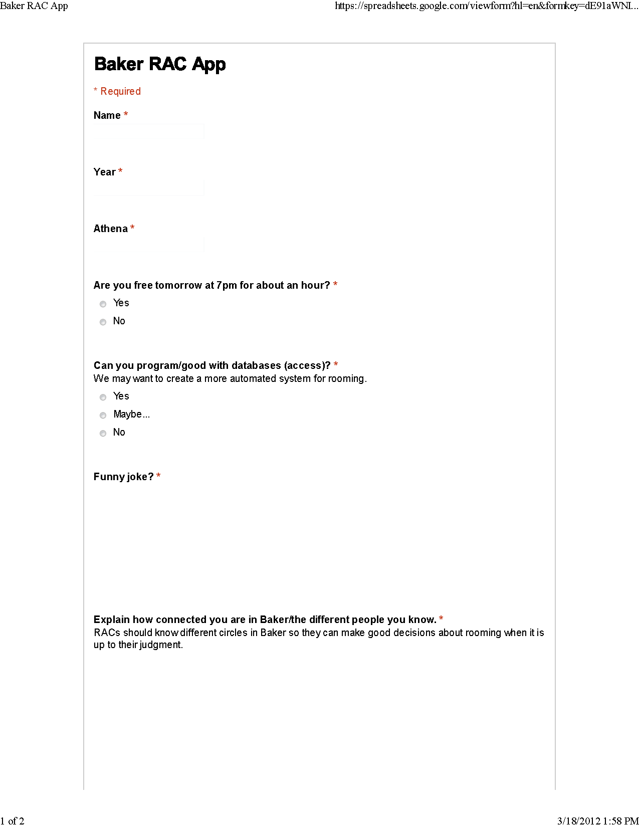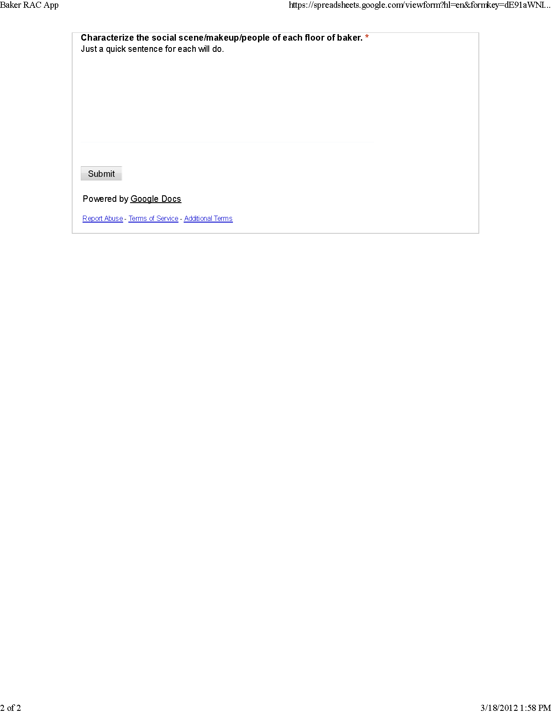

Figure 3 2011 Upperclassmen Room Preference Sheet 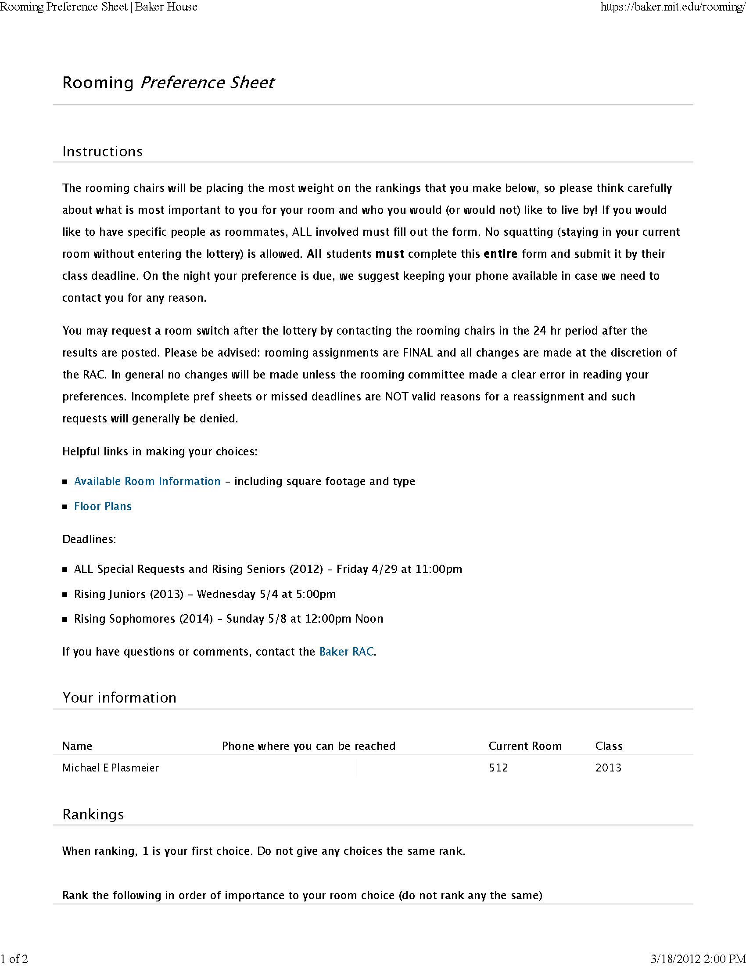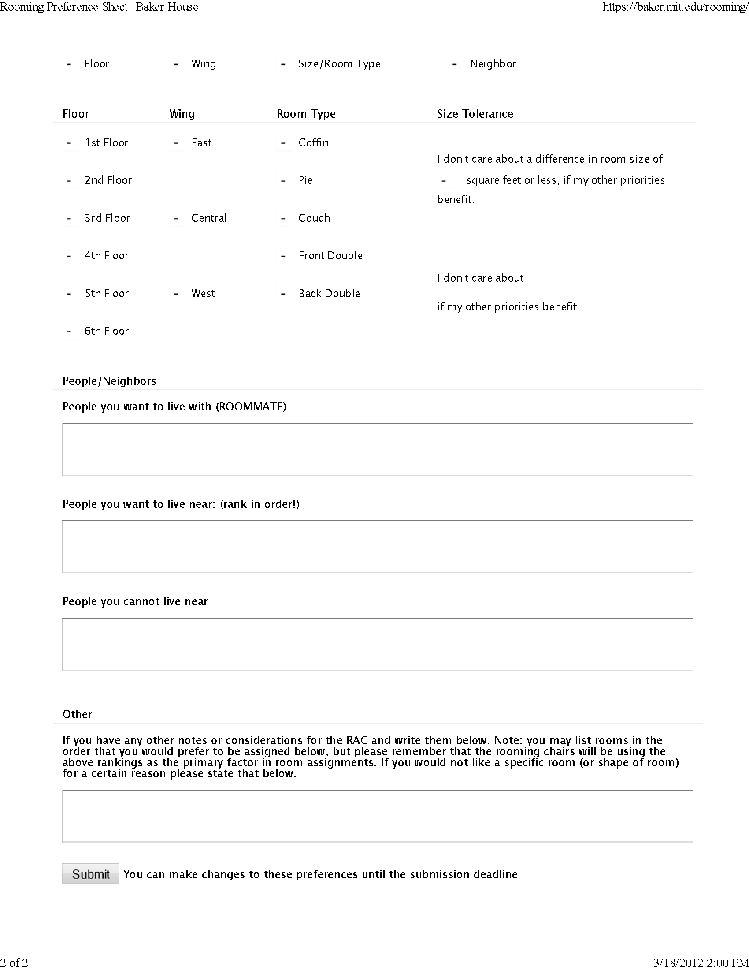

In 1950, a study by Festinger, Schachter, and Back at MIT, showed that friendships and information dispersal strongly correlated with the distance between apartments and the apartments a resident passes on the way in and out of the building

