Baker Rooming Polices Review DRAFT
Research has shown that the assignment of rooms in a dorm has a very significant impact on the friendship and culture of a dorm. Because of the impact of rooming, the rooming process is important to maintaining Baker culture. Because of the importance of this process, it is vital that the process operate well and reliably year after year.
The Baker Rooming policies have not been formalized and made available to residents in written form. Because of the lack of information, residents must rely on second hand information about the process from upperclassmen. This causes unnecessary anxiety about the process. At this point in time, Baker Exec has decided to formalize the Baker House Rooming Policies. At the same time as this formalization process is taking place, small tweaks or major revisions may be introduced into the process.
Through the rooming review, it has become apparent that one part of the process requires a substantial revision. Students have raised concerns about the selection of the Room Assignment Committee (RAC). This review attempts to address those issues by proposing to base the selection of the RAC partially on objective criteria.
In addition, more can be done to help incoming freshmen find the proper roommate. Freshmen roommates have been shown to have a significant impact on a student’s growth and academic performance. It is vital that freshmen find the right roommates. This review proposes moderate reforms to the process in which freshmen find roommates.
Under the Baker Constitution, the Room Assignment Committee (RAC) has always operated as a unit of Baker Exec. However, in the past few years the RAC has operated independently of Baker Exec. This Review reaffirms the RAC’s position as a unit of Baker Exec.

Guiding Principles
Throughout the rooming review, the following guiding principles were followed:
- The RAC should continue to select students according to a discretionary, holistic process, as opposed to a mechanical process.
- Residents shall be roomed according to their personal preferences, as opposed to an “interventionist policy” that would attempt to radically reshape the dorm
- Residents are in the best position to select their own roommates, neighbors, and room locations that the RAC will take into account in room assignment
- Rooms shall continue to be assigned based on seniority

Transparency of Rooming Regulations

Current Situation
Rooming process information not posted on the Baker website.

Proposed Process
This document shall be posted on the Baker website.
The list of rooms available shall also be posted at all times of the year.

Room Assignment Committee (RAC) Makeup

Current Makeup

Four members, one each from the sophomore, junior, and senior classes, plus the President ex officio.
(However, the current rooming committee is made up of two juniors and a senior)

Proposed Makeup
No change. The members other than the President are defined as the permanent members.

RAC Member Selection

Current Process
The new member is selected before the Upperclassmen Selection Process.
Current RAC members issue an application and solicit responses. There are no guidelines on the way the application is issued or the way responses are collected.

A new member is selected sophomore year, to serve on the rooming committee for the rest of their time in Baker.
The current RAC selects the new member who is well connected in Baker, has a good work ethic, and if needed, has knowledge of database systems.
The member must be ratified by the house at the final house meeting of the term. However, this has not happened for the past few years.
RAC members may not be Exec members

Proposed Process
The new member continues to be selected before the Upperclassmen Selection Process.
Exec members may now serve on the RAC.

Application Process
The Baker Secretary shall issue an application, solicits responses, collect responses, and distribute copies of the responses to the President and the RAC.
The Secretary shall allow no less than 5 days between the date the application is distributed and the date the application is due.
The Secretary shall take steps to publicize the availability of applications. The Secretary shall notify the dorm using the baker-general mailing list, among other methods.

A new member is selected sophomore year, to serve on the rooming committee for the rest of their time in Baker.

Point System
Applications are scored by the Secretary based on a points system. The final, itemized allocation of points shall be posted publically by the Secretary. The requirement for ratification is removed.
The applicant from applicant pool with the most points is granted a spot on the RAC. Points are assigned in the following way:

Petition Process
The Secretary shall designate a petition time frame. The petition time frame shall be published with the opening of the applications. The petition time frame shall last no shorter than 72 hours.
An applicant may circulate a physical (ie. paper) petition to residents of the House. For every 2 unique signatures, an applicant shall receive 1 point, up to a maximum of 150 signatures/75 points.
For example, a petition signed by 100 residents of Baker, will equal 50 points.
Petitions should be turned into the Secretary who will verify the names.

Current RAC Members
The junior and senior members of the RAC each have 20 points to distribute to applicants based on the merits of their application. They may not assign more than 10 points to any an individual applicant. Points may not be subdivided.
Since there are 2 permanent members at this point in time, an applicant can receive a max of 20 points through this process.

House President
The President has 40 points to distribute among applicants based on the merits of their application. No applicant may receive more than 20 points from the President. Points may not be subdivided.

Objective Criteria
Points shall be assigned subject to the following table:
Each Semester Lived in Baker | 5 points
Regular attendance (>50%) at Exec meetings (as designated by the Secretary) | 20 points per semester
Serving in an elected or officer position on Exec (in addition to above) | 15 points per semester

Upperclassmen Assignment Process

Current Process

Rooming Pools
The RAC conducts 3 separate rooming processes on separate days (the rooming days). On each day, the RAC rooms separate applicant pools. On the first rooming day, the RAC rooms rising seniors (current juniors); on the second rooming day, the RAC rooms rising juniors (current sophomores); and on the third rooming day, the RAC rooms rising sophomores (current freshmen).
On each rooming day, the rooming committee divides the applicant pool into 2 sub-pools: current Baker students and students transferring into Baker. On each rooming day, the RAC first rooms all current Baker students, and then rooms all incoming transfer students.

Order of Rooming Pool
For each sub-pool, the RAC randomly sorts the list of students in that sub-pool (the random ranking). The random ranking is an ordered list from 1 to N, where N is the number of students in that sub-pool.
The RAC assigns points to applicants based on their participation in dorm activities. The RAC issues points according to a point chart:
(Insert current point chart)
These points are subtracted from that resident’s position in the random ranking, to create an intermediate rank score. The list of students sorted by intermediate rank score is called the final ranking. Ties are resolved by an arbitrary method. For example, a student with a random ranking of 20, but earning 10 points for participating in Exec, would have a rank score of 10. If no other students received points, that student would have a final rank of 10, and all other students with an intermediate rank score >=10 are one position lower in the final ranking than in the random ranking.
If a student has a valid medical or other requirement, filed through the MIT Housing Office, those students are given special consideration.

Room Preference Sheet
Several days before the start of the rooming process, the RAC issues a room preference sheet. All students interested in living in Baker fill out a preference sheet and submit it to the RAC by the deadline indicated by the RAC.
The sheet asks students for their preferences in a number of categories, including floor, wing, neighbors, room type/size. The room preference sheet has a section where residents can indicate the relative preference for each category. Students may also list a rank order of specific rooms. The 2011 Roof Preference Sheet is attached to this document.
The sheet also has a phone number field. During the rooming meeting, residents should remain accessible by phone.

The Rooming Meeting
On each rooming day, the RAC enters into a closed meeting (the rooming meeting) to conduct the rooming process. The RAC reads each form in the order of the final ranking of each sub-pool.
The RAC than evaluates each application holistically, taking into account the preferences listed on the sheet, the balance and makeup of the dorm, preferences expressed by the House Masters, GRTs, House Manager, and Exec. If the RAC has additional questions, they will call the resident.
If someone lists a preference for a roommate, they will be placed together, no matter the roommates place in the ranking.
At the end of each rooming day, the RAC posts the assignment of rooms and the list of rooms still available.

Preferences regarding Current Room/Floor
Current residents of a particular room have no automatic right towards their current room for either themselves (ie. squatting) or others (ie. willing), nor to their current floor.
The RAC will not assign residents a worse room than they currently have. In practice, residents are almost always able to keep their current room next year.

Proposed Modifications
The process will remain similar, with the following modifications:
The RAC shall post the random ranking for each sub-pool, the points received by each resident, the final ranking for each sub-pool.
The room preference sheet will contain a summary of the information presented herein, with a pointer to the full policy.
Before the rooming process, the House Manager will inform the RAC of all rooms which are unavailable for the upcoming semester and which are protected for reasons designated by the House Manager. The RAC shall post the list of rooms which are designated as unavailable by the House Manager, but may not necessarily post the reasons such rooms are unavailable.
The process will be clarified to define 9th term seniors as seniors.

Transfer Assignment Process

Current Process
Transfers are students who are moving into Baker House at a time other than the REX Assignment period, or the period before the Upperclassmen Assignment period.
MIT Housing notifies the RAC and the House Manager that a student is moving into Baker. The RAC will issue the student a room preference sheet. Upon request, the RAC provides the new resident with a list of available rooms. The House Manager and RAC work to will pick the best available room which matches the new resident’s preferences and works logistically.

Proposed Process
The process will remain the same.
In the future, work should be done to smooth the logistical burden of the process, while maintaining flexibility for students.

Summer Freshmen Temp Room Assignment Process

Current Process
MIT Housing sends the RAC a list of students that have been assigned Baker in the Summer Housing Lottery. MIT Housing also sends information about the student’s preferences, as collected during the summer housing lottery, to the RAC (the summer preferences).
Currently the RAC assigns students to temporary rooms based on the alphabetical order, while taking into account the student’s summer preferences.
If a student requests a specific roommate, they will be matched with that roommate.

Proposed Process
The rooming committee shall assign freshmen randomly to temporary rooms, while avoiding clear conflicts of compatibility from the student’s summer preference sheet. Students have an opportunity to remain with their roommates or find new ones during the post-REX Freshmen Assignment Process.
If a student requests a specific roommate, they will be matched with that roommate.

Post-REX Freshmen Room Assignment Process

Current Process
During REX, the RAC advises freshmen to look for compatible roommates.
After REX, all incoming Baker freshmen (including those assigned to Baker in the Summer Housing Lottery and those assigned to Baker in the REX Lottery) gather in front of Baker House at a designated time. At that time, Exec and the RAC introduce themselves and the rooming process. Freshmen are given approximately an hour to mingle with other freshmen.
Freshmen then fill out the same Room Preference Sheet, as described above. If freshmen want to live together, they staple their sheets together to form a group.
The RAC then enters into a Rooming Meeting, as described before. The RAC first assigns freshmen with valid medical or other requirements, filed through the MIT Housing Office. The RAC then assigns 4-person groups to quads. The RAC then assigns other students according to a holistic process. Unlike the Upperclassmen process, the applications are not reviewed in a specified order. Groups are not broken up, but other freshmen may be
Proposed Process
Before the mingle period, a new event, preliminary titled Rotations, will structured as follows:
Two separate rotations will be established for each gender. Freshmen in each gender will be designated as A, B, and C. One A, B, and C will meet up to form a huddle. They will then introduce themselves and discuss what they are looking for in a roommate. After a designated period of time, the freshman with a designation of B will move to the huddle to the left, and the freshmen from designation C will move to the huddle on the right. This will continue until the students circle around to their original huddle (or 2 of the 3 members).
The process is being structured to help all freshmen get to know the other members in their class. Rotations will be a test event for the Class of 2016. Exec and the RAC may decide to modify or discontinue the event at its discretion, without following the full procedure to modify the bylaws.
added to a group. For example, a two person group may be assigned a triple with a third person.
The RAC then posts the room assignments.
Freshmen are encouraged to pick roommates with similar sleep schedules, and who share their expectations about partying.
After Rotations, there will be a shorter mingle period as before.
Separately, the process will be clarified that students who wish to room together must only fill out only one preference sheet for their group.

Gender
(no change)
Baker House is a co-ed dorm. Students shall not be segregated by gender by either floor, or section of the floor. Instead, effort should be made to intersperse males and female rooms.
Only students of the same gender may be assigned to share a room.

Switching
(no change)
If students work out a mutual switch, the RAC will honor the switch.

Transition
The 2010-2011 RAC did not follow the prior Baker Bylaws, and selected two sophomores. This is contrary to the Baker Bylaws. To maintain the objectivity of the Room Assignment system, the RAC should conform to the Bylaws as soon as possible. The two current juniors shall mutually agree on a method to decide who should continue to serve on the RAC as the member of the junior class.

Exec Meetings
From time to time, the RAC shall come to Exec Meetings to keep Exec informed about the rooming process. In particular, the RAC should come to the meeting before the opening of the Upperclassmen Selection Process.

Rising Seniors
Current Baker Residents

Rising Seniors
Incoming Transfers

Rising Juniors
Current Baker Residents

Rising Juniors
Incoming Transfers

Rising Sophomores
Current Baker Residents

Rising Sophomores Incoming Transfers

Day 1
Day 2
Day 3
Figure 1 Room Sub-Pools

Figure 2 2011 RAC Application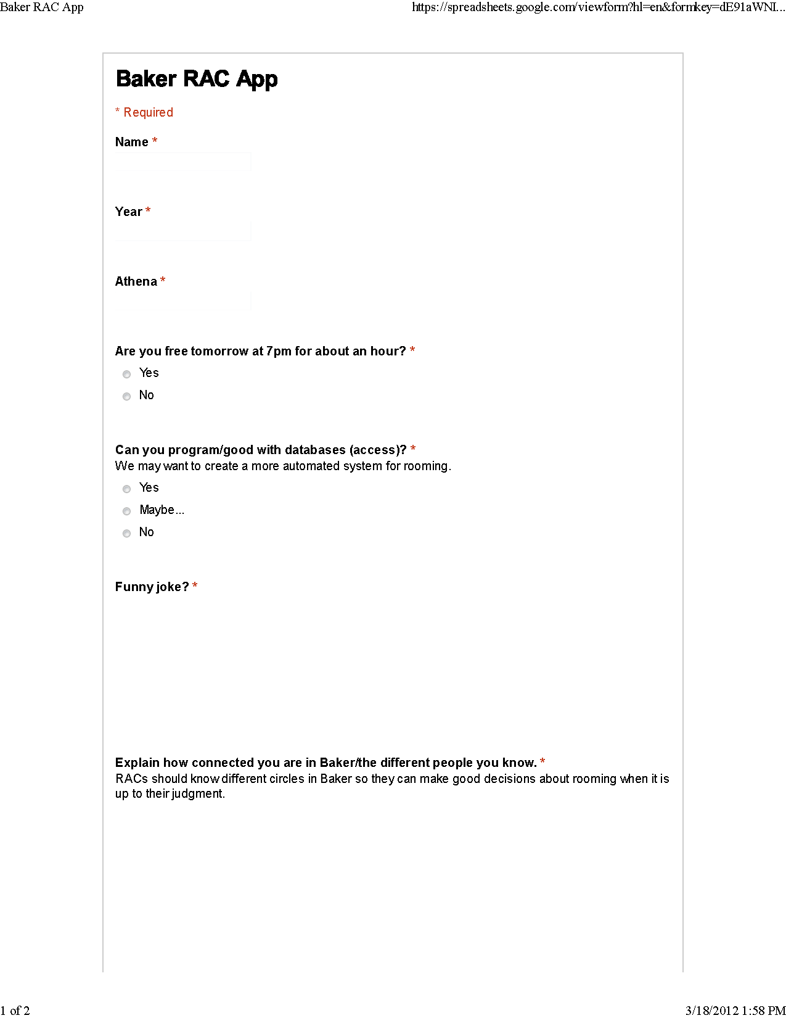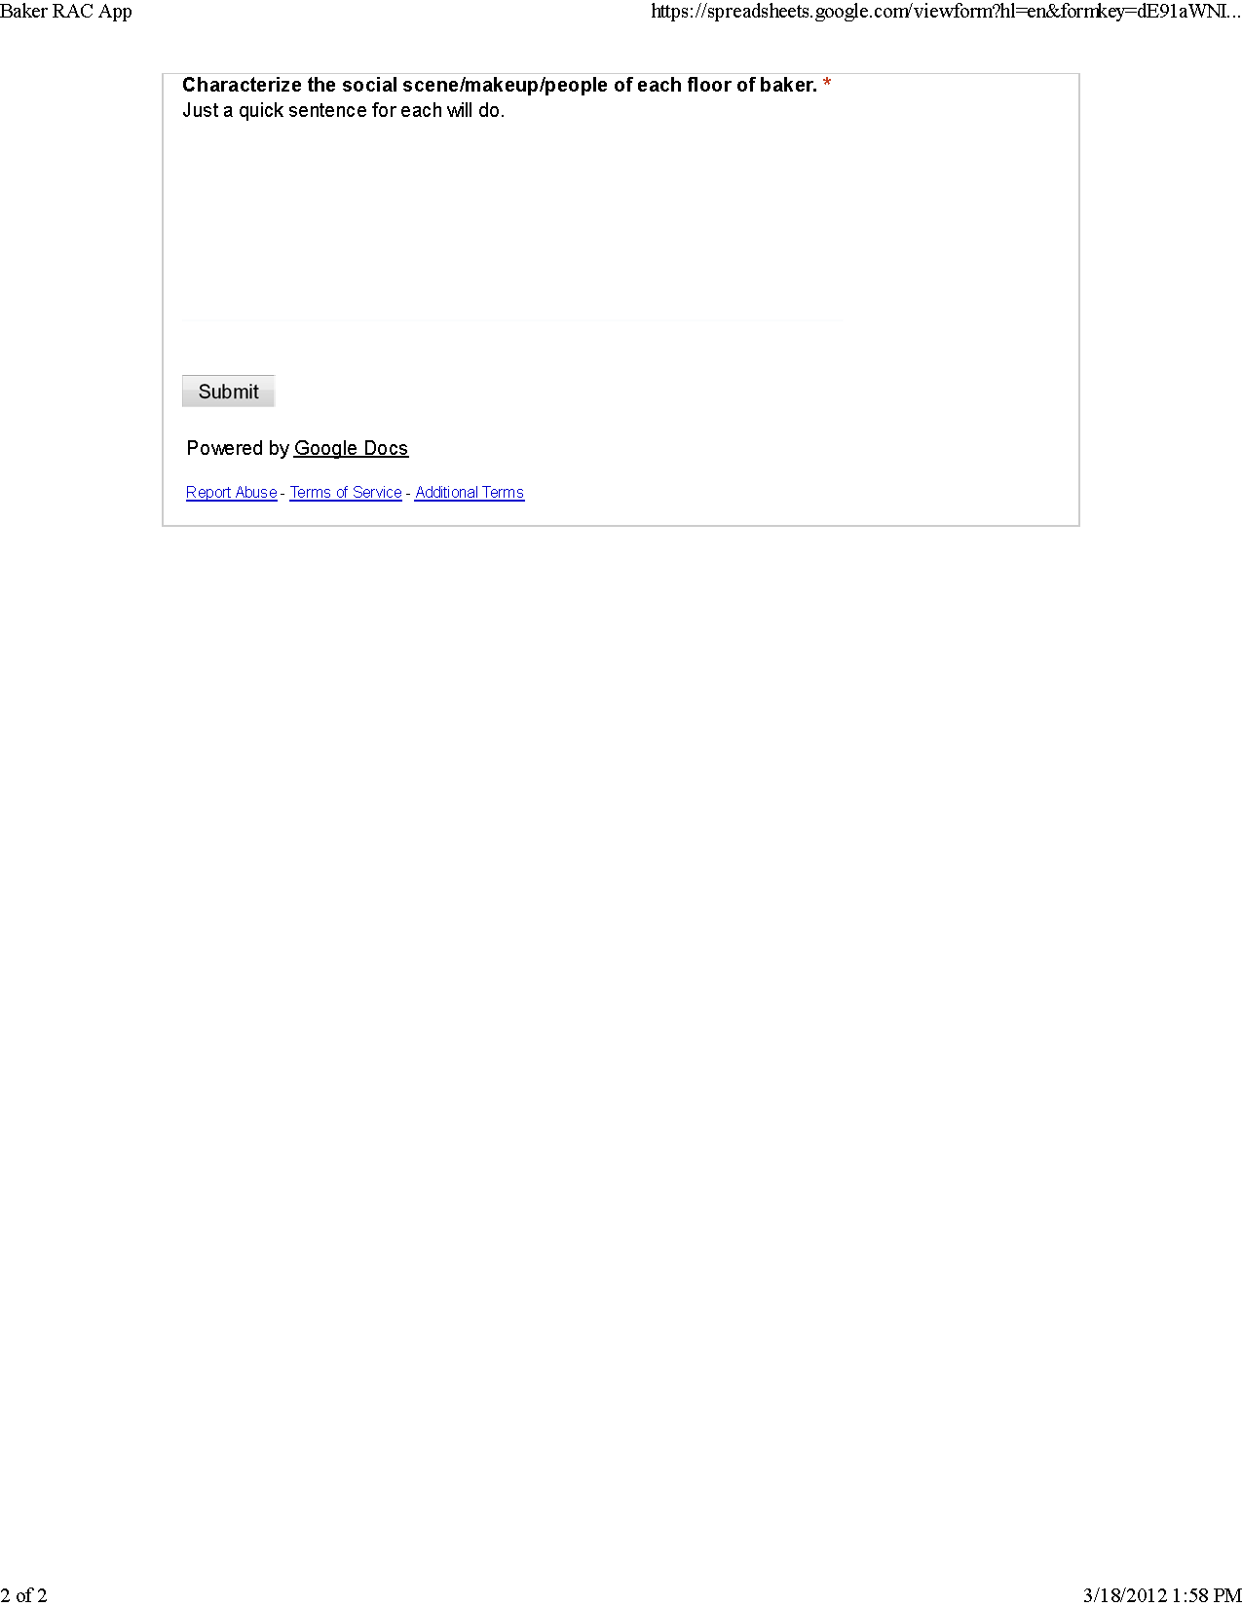

Figure 3 2011 Upperclassmen Room Preference Sheet 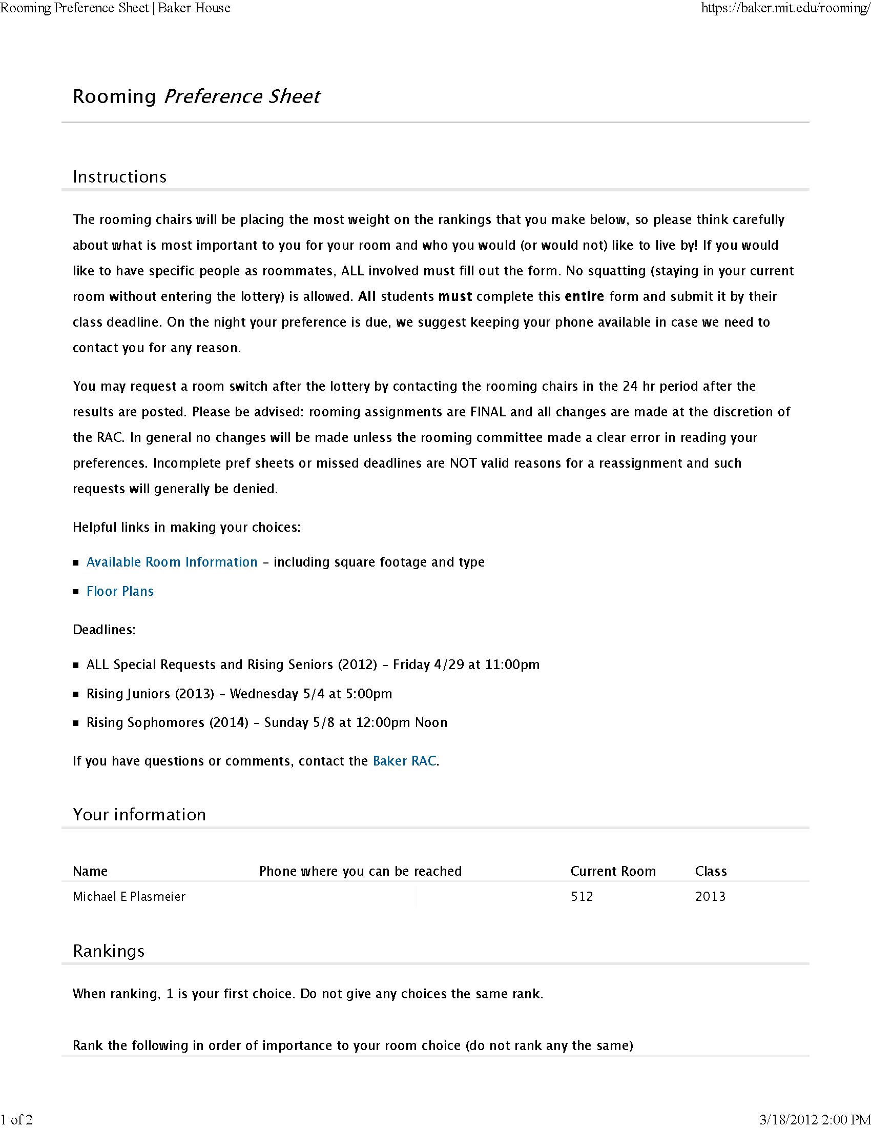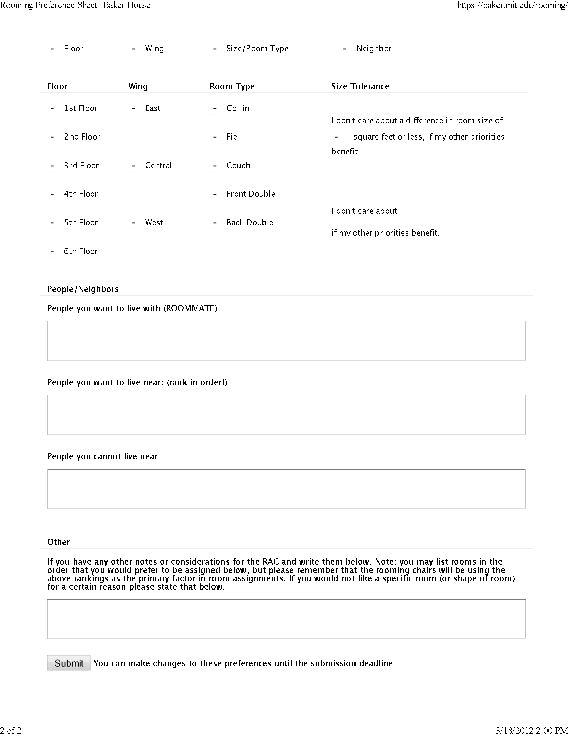

In 1950, a study by Festinger, Schachter, and Back at MIT, showed that friendships and information dispersal strongly correlated with the distance between apartments and the apartments a resident passes on the way in and out of the building

