HW2: Career Portal Mashup
Michael Plasmeier
A career portal mashup could help the MIT Career Development Office (CDO) better serve students by combining several sources of relevant information into one place. The system would combine existing data privately available to MIT with data from the user’s social network as well as publicly available data from various websites.

Functionality
The system should be able to provide:
- a large number of jobs from public and private (to MIT) sources
- general information about the details and trends of a particular occupation
- reviews and additional insights about a particular company from public and private sources
- the contact details of people the users either knows personally or members of the MIT alumni network affiliated with or were previously affiliated with a particular company
- details about the salary ranges at a target company from public and private sources
- information about the living conditions in the city in which the target position is located
- details about a particular company from both stock analysts and social media mentions from sources both personal to the user and the general public

Strategic Value
The mashup system would help the CDO better serve students.
- It would combine information from many places into a single page or series of pages, saving students time and hassle.
- It would present information that students would not otherwise has seen, allowing students to make better career decisions.
- It would allow students to better help themselves; giving students answers quicker and reducing the need for staff to answer routine questions.
- It would allow for MIT students better connect with their existing social networks about a particular job. Research has shown that about 56% of respondents in one survey found a job through interpersonal connections, the majority of them being “weak” ties, such as both being a member of the same social network.
- It would strengthen ties with alumni. Alumni who feel more engaged with a school are more likely to donate.

Data Sources
Generally, the data shown follows this pattern: first, information from a user’s friends; second, information from the MIT Alumni network; and finally, information from the general public.

The mashup system would use the following data sources: Each option could be turned off, if a student only wanted to see a certain kind of information.
- The existing private job listings on MIT’s Career Builder
  - This listing of the existing jobs available to MIT students would form the base of the mashup on which the additional information is presented.
- Private job listings on other MIT career sites, such as MISTI
  - MIT has several offices that maintain listings of jobs. It would be beneficial to bring them all into one place.
- Job listings from public sites, such as Monster.com and Career Builder
  - This is probably the least helpful section, but it a student is looking at a field that does not traditionally recruit at MIT, these publically available jobs could fill in the gap.
- A system where MIT alumni can post workplace/company reviews visible only to current MIT students
  - Private reviews would build on the reviews available from Glassdoor but would be different in two key ways. They would be from the perspective of a MIT student – a student who has a similar background and training – so they would be more relevant. In addition, because they would only be visible to current MIT students, they would be more private, allowing alum to go into more details than they might feel comfortable doing publically.
- Public workplace/company reviews from Glassdoor.com
  - Public reviews from Glassdoor would fill in the gaps when no reviews from MIT alumni are available.
- The MIT Alumni Database of Alumni currently/previously worked at the company
  - Alumni might have not posted their review, but many are happy to talk to you about the company they are working at. You can also ask for additional insights beyond what is posted in a review.
- The current user’s LinkedIn connections to people currently at/previously at the company
  - Many students do not check their LinkedIn profiles for contacts at their target company. This would get them in the habit. Research has shown that many jobs are secured through personal connections.
- A system where MIT alumni can post salary information visible only to current MIT students
  - One of the biggest black boxes in recruiting is salary and offer information. This section of the site would allow MIT students/alumni to post their offers, allowing students to see if it’s worth applying before they go through the long process. It would also contain student’s results in negotiating – what did they ask for and what did they end up with.
- Public salary information from Glassdoor.com
  - Again, gaps in information from MIT students would be filled in with information from Glassdoor.
- Industry Salary information from Salery.com
  - Salery.com has data on salaries at the industry level. This allows students to evaluate your offer against other companies in the field. If students feel the offer they receive is too low, they can use this data to negotiate to raise it.
- Occupational profiles from the Bureau of Labor Statistics
  - Most MIT students know the basics of the field they are getting into. However, for the students that are unsure or early in their studies, this information could help them understand the trends in a particular industry.
- Facebook/Twitter mentions of the company from the user’s friends/contacts
  - Users might not have a sense for the perception of a company. This would search a user’s Facebook friends and twitter contacts to see if any of the friends or connections mentioned a company.
- Facebook/Twitter mentions of the company from MIT alumni
  - If there is no information from a user’s friends, the system would fall back to the MIT alumni network.
- Facebook/Twitter mentions of the company from the general public
  - If there is still no information from the alumni network, the system would fall back on information from the general public.
- The user’s MIT friends who are/will take a job in that same geographic area
  - One component of deciding where to take a job is where the job is located. This would let you easily see which of your friends have also taken a job in the same area
- MIT Alumni living in a particular area that are willing to provide insights on the housing market in that area
  - If you are trying to find an apartment, it’s helpful to have local knowledge about an area. Alumni could give you a primer on the market and the culture of each section of the city.
- A calculation of living costs in a particular city from industry sources
  - This information could be used to compare multiple offers and as a bargaining tool.

Data Sources Deep Dive

Glassdoor
http://www.glassdoor.com/Salary/Apple-Salaries-E1138.htm 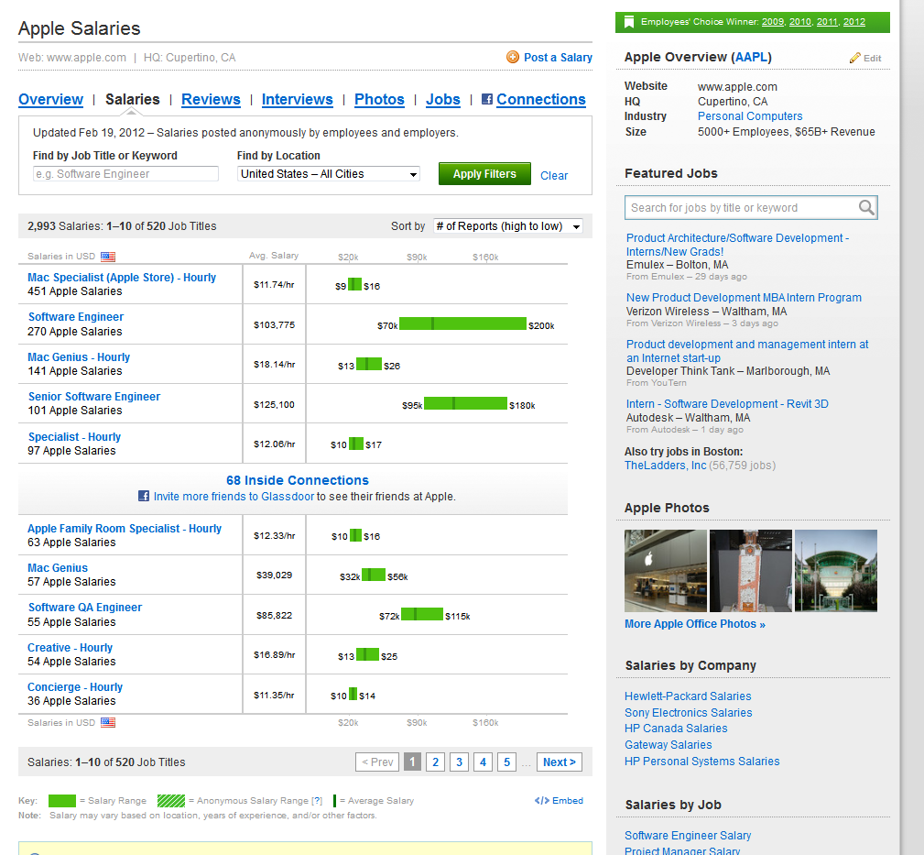

Facebook Mentions
http://www.facebook.com/{Page}?sk=friendactivity

MIT Alumni Database(Infinite Connections)
http://alumic.mit.edu and then search for the company
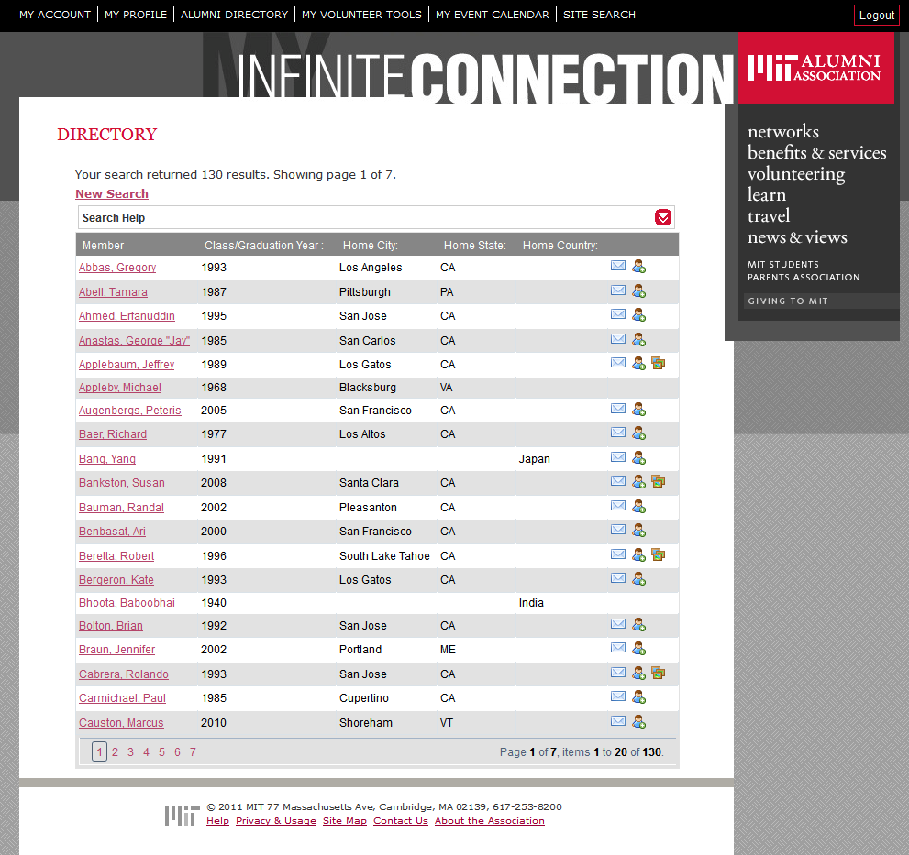

Organizational and Legal Issues
- Companies may not want their sites scraped
  - We could stick to data with published APIs or negotiate an agreement with the company.
  - We could take the legal position that database data is not copyrightable and prepare the legal team to defend our position.
- Some companies only display information to users who have created an account
  - We could have users create an account and then link that account to the mashup in order to retrieve information.
- Users may not want to log in with their passwords to other sites
  - We could display information from the MIT Alumni network as a fallback.
- MIT offices might not like that we are now aggregating their job databases
  - Explain to them how this effort ultimately benefits students who now have more opportunities in one place.
  - Explain how it is likely that more people will now use programs like MISTI, because they found out about those programs from the CDO database.
- The format of the underlying data changes after the site is created
  - We could maintain a contract with a programmer who can quickly update the scraper to match the new format.

https://career.berkeley.edu/article/060915a-db.stm
http://case8pdx.org/pdfs/alumni/Ipsos_SAIT%20Alumni%20Engagement.pdf

