Autosomal recessive
In this example, two unaffected parents each carry one copy of a gene mutation for an autosomal recessive disorder. They have one affected child and three unaffected children, two of which carry one copy of the gene mutation.
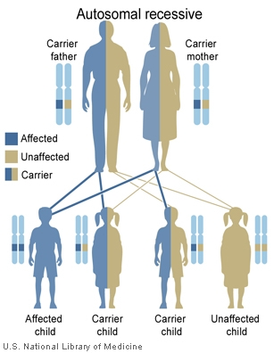

Autosomal dominant
In this example, a man with an autosomal dominant disorder has two affected children and two unaffected children.
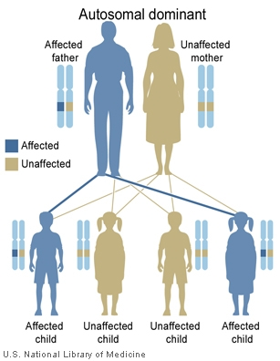

X-Linked dominant (affected father)
In this example, a man with an X-linked dominant condition has two affected daughters and two unaffected sons.
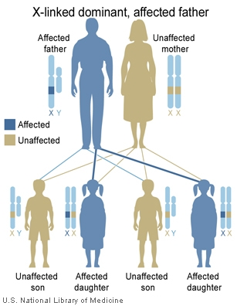
X-Linked dominant (affected mother)
In this example, a woman with an X-linked dominant condition has an affected daughter, an affected son, an unaffected daughter, and an unaffected son.
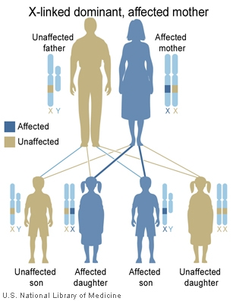

X-Linked recessive (affected father)
In this example, a man with an X-linked recessive condition has two unaffected daughters who each carry one copy of the gene mutation, and two unaffected sons who do not have the mutation.
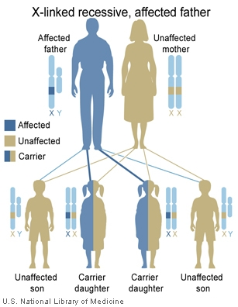
X-Linked recessive (carrier mother)
In this example, an unaffected woman carries one copy of a gene mutation for an X-linked recessive disorder. She has an affected son, an unaffected daughter who carries one copy of the mutation, and two unaffected children who do not have the mutation.
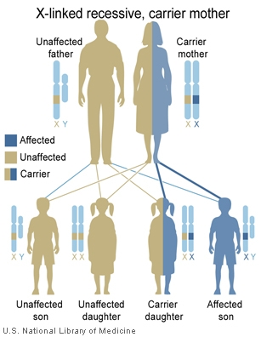

Codominant
The ABO blood group is a major system for classifying blood types in humans. Blood type AB is inherited in a codominant pattern. In this example, a father with blood type A and a mother with blood type B have four children, each with a different blood type: A, AB, B, and O.
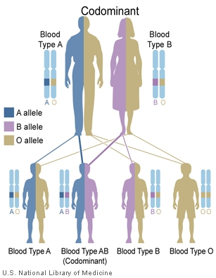
Mitochondrial
In one family, a woman with a disorder caused by a mutation in mitochondrial DNA and her unaffected husband have only affected children. In another family, a man with a condition resulting from a mutation in mitochondrial DNA and his unaffected wife have no affected children.
