
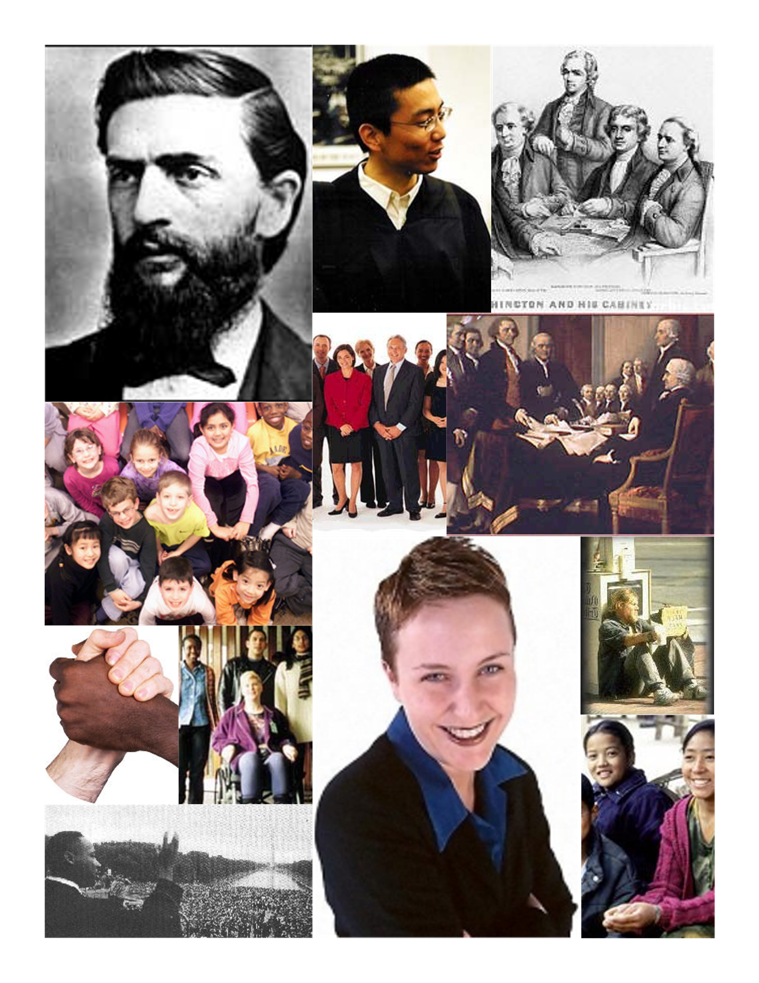
This statement starts out the new Constitution of the United States of America as the opening. It tells us that we the people are doing something, not a king, or a monarch, or a state. It is a nice intro to the Preamble, however according to Jacobson v. Massachusetts, the Preamble does not guarantee citizens anything.

My college is a college of diversity. It shows who is now involved in We the People. Nowadays, everyone is now involved in We the People and gets treated equally in our nation. African-Americans, Asians, Women, Homeless, and Disabled Americans. They all now have equal benefits under We the People, and are displayed above. In the days the founding fathers, only white, land-owning [rich], men, were included in We the People. Notice, that there are no kings or queens who are singled out in We the People.

