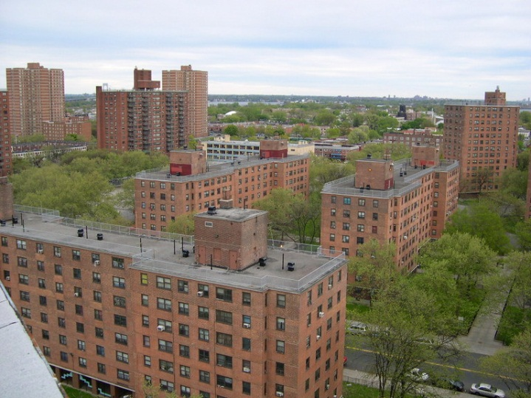
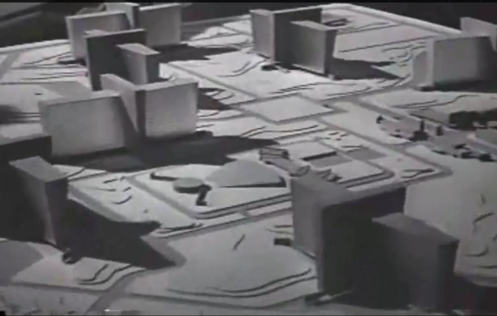
The Modernist Architectural Style
Roark’s Cortlandt Homes
New York City Public Housing
I think there are some interesting incongruities with Roark’s architectural style, at least as it is shown in the 1949 film The Fountainhead. The modernist style Roark builds in is today regarded as a mistaken, socialist detour in the history of architecture. Not only did Communist nations embrace the same plain, un-adorned style Roark favored, but Roark’s plans for Cortlandt Homes pay a distinctive resemblance to much of public housing built in New York after the publication of Rand’s book.
In these projects it was fashionable to remove the old, “dilapidated” housing in poor areas and replace it with large scale, public developments. Some critics, such as Jane Jacob’s 1961 Death and Life of Great American Cities severely criticized these “slum clearances” as replacing perfectly good neighborhoods with drug-filled crime havens as public housing. Roark and Friedman would have undoubtedly strongly opposed government housing and the forced slum clearances done in the name of the poor. The forced clearances represented a very liberal, paternalistic thinking on behalf of the government over the individual that both Friedman and Rand would have found abhorrent. Friedman even speaks against public housing on page 178 of Capitalism and Freedom.
Today, we almost exclusively criticize the modernist projects Roark championed as out of scale with the surrounding environment. This period gave rise to the architectural preservationist movement. We mourn the buildings that were torn down to build these new modernist structures, such as the Madison Square Garden over the old Penn Station. Afterwards and still today, the new urbanism movement is a rejection of many of the ideals from during and after the modernist era.
I wonder what Roark would have thought about the government adopting his style of architecture and forcing it on the urban poor.
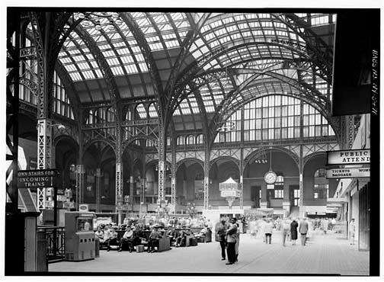
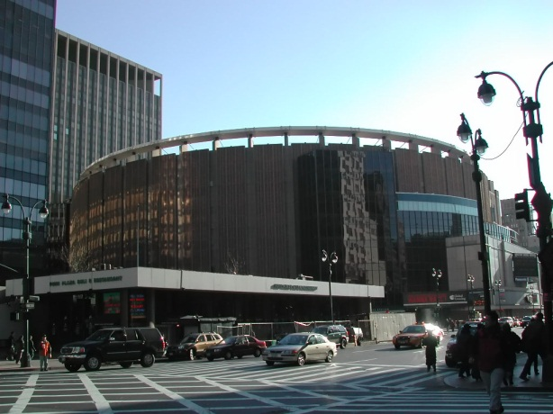
New York Penn Station Pre 1963
Penn Station Today: The Madison Square Garden

