**Cooking Classes @ MIT**

Idea Proposal and Evaluation

Cathy Cao

cjcao@mit.edu

Diandra Drago

ddrago@mit.edu

Neel Hajare

hajare@mit.edu

Michael Plasmeier

theplaz@mit.edu

Amy Zhang

lingyiz@mit.edu

Group Report

15.279 Final Project

Spring 2011



Prof. Terence Heagney

Campus Consulting Company

84 Massachusetts Avenue, Cambridge, MA 02139

April 28, 2011

Mr. Henry Humphreys

Senior Associate Dean, Residential Life and Dining

Dear Mr. Humphreys:

A month ago, Campus Consulting Company (CCC) was asked to look into the details of operating cooking classes at the Massachusetts Institute of Technology (MIT). We were first asked to establish whether there was sufficient student demand for such a program. If we found that there was enough interest, we were asked to think through several different ways that the program could be operated and provide a recommendation.

Suggestions of cooking classes have been floating around campus for the past few years. Not only do cooking classes help students not on house dining plans eat healthful meals, but they can help all students cook for themselves after graduation. However, up to now, no formal study has been conducted to evaluate the idea of providing a campus-wide cooking class.

In order to establish a need for cooking classes, the CCC first surveyed undergraduates from dorms on both the east and west side of campus, as well as select FSILGs. We also talked to administrators who have been thinking of setting up programs in the past. After establishing an interest level, we explored ways to set up a pilot program. We believe that a pilot program can help MIT try out different ways of operating the program before dedicating and renovating a space for the program. We looked at curriculum, staffing, length/frequency of classes, and location. We also explored the possibility of offering PE credit. Finally, we also accounted for the cost of our recommendations and identified resources that could cover the cost, providing a holistic view on the program.

The idea of cooking classes is a creative solution to both student health and dissatisfaction with the dining plan. Although the sizes and expenses of the ultimate program may vary, we believe that it is feasible to set up a pilot program without a large commitment of resources.

As an objective student consulting group, our goal is to provide as much information as possible to help you make the best decision. Therefore, if you have any additional questions, please email me at [theplaz@mit.edu](mailto:theplaz@mit.edu).

Finally, Campus Consulting Company would like to thank you for the opportunity to work with you on this issue.

Sincerely,

Michael Plasmeier, Partner

Campus Consulting Company

## Executive Summary

### Purpose

The purpose of this report is to analyze the possibility of operating a campus-wide cooking class at MIT.

### Background

Over the past few years, MIT has sought to help students eat well so that they can perform their best in class. In order to achieve that goal, MIT has moved to implement a meal plan in five of the dormitories. However, the meal plan does little to help students become self-sufficient after graduating from MIT. In addition, current efforts have largely bypassed those who live in dorms that cook for themselves.

Costantino Colombo, the Dean for Student Life, has acknowledged that more can be done to help students eat well, particularly at cook-for-your-self dorms. Henry Humphries, Senior Associate Dean for Residential Life and Dining and Director of Dining Richard Berlin, have also shown interest in a cooking class program.

### Research

We conducted interviews with members of the administration, including Richard Berlin, Director of Dining, and Carrie Moore, Director of Physical Education. We also talked to other members of the administration and one food vendor at MIT.

We also conducted a survey which was distributed among undergraduates at MIT. 246 people responded. Questions included where the cooking class should be located, how often the class should be held, and whether the students would be willing to pay a fee.

### Findings

Students are clamoring for cooking classes. Of the 246 people who responded to our survey, 86% of respondents said that they would be interested in a program. We believe that in order to test different concepts that the program first be established as a pilot program, which requires a minimal commitment of resources. Based on our conversations, we believe that there are current chefs on campus who are willing to volunteer to teach the class. Respondents want an intermediate-level curriculum and we feel it is important to cover food safety. We found that IAP would be the best time for the class, but we have also identified how the program could work during the semester. After evaluating many different spaces, we found that Next House had the largest feasible space for the pilot program. We believe offering PE credit would not be feasible. We’ve found that a pilot program is feasible for very few resources.

Table of Contents

Executive Summary 3

Purpose 3

Background 3

Research 3

Findings 3

Introduction 5

Background 6

Methodology 7

Student Interest 8

Staffing 13

Curriculum 14

Time 16

Location 18

Considerations 18

Alternative Locations 20

PE Credit 22

Cost 23

Conclusion 24

Appendix A: East Campus Cooking Class Advertisement 25

Appendix B: Survey 26

Appendix C: Requirements for a PE Class 29

Appendix D: Draft Class Plan from PE Department 31

Appendix E: Survey Results 32

## Introduction

First this report reviews some of the events leading up to this study and a survey of the current sentiment on campus is for cooking classes. Next, the report establishes a strong student interest in a cooking class through the use of a survey. The report then explores several possible staffing arrangements before recommending a staffing profile. This report then suggests a curriculum for the program. After that, the report explores possible durations of the class, and what time of year that the class could be offered. Again we provide a recommendation. Next, the report establishes criteria for the selecting the location of the classes. We then evaluate several on-campus locations according to the criteria before recommending a location for the pilot. Next we evaluate whether the class could qualify for PE credit. Finally, we review the costs associated with our recommendations and propose a funding mechanism.

## Background

Over the past few years, MIT has sought to help students eat well so that they can lead healthy lives, both at MIT and afterwards. In order to reach this goal, MIT has moved to implement a meal plan in five of the dormitories. However, much remains to be done to achieve the goal. The meal plan does little to help students become self-sufficient after graduating from MIT. In addition, current efforts have largely bypassed those who live in dorms that cook for themselves.

Dean for Student Life Chris Colombo has acknowledged that more can be done to help students eat well, particularly at cook-for-your-self dorms. Henry Humphries, Senior Associate Dean for Residential Life and Dining and Director of Dining Richard Berlin, have shown interest in a cooking class program.

There is currently a cooking class at East Campus taught by Victoria Davenport, a Senior Administrative Assistant. One student we contacted was satisfied with that program in its current format. However, this program is designed for East Campus residents. We believe that a program should exist which is open to all students.

In response to the selection of Bon Appetite Management Company, Bon Appetite has been trying to get to know the students better. As a result they have offered to lead cooking classes. Bon Appetite is planning on running a series of one-day seminars, one in each dorm.

In our discussions with Richard Berlin we learned of his plans to create a more extensive cooking class. Richard showed us his plans for a 6-class series of cooking classes. The class would start with a heavy emphasis on safety and product identification early on, and then transition to more detailed techniques later on.

Richard also shared with us his dream that a student-kitchen be established. Similar to the Edgerton shop and the glass blowing lab, students would be introduced to the kitchen through an introductory class. After going through the class, students could use the kitchen to prepare meals for their student group

However, setting up a permanent cooking class will represent a substantial investment to MIT. While MIT has made these types of investments in the past, we felt that a test program should be established in order to plan for a more permanent program. This test program would help MIT test different models before committing to a full-time facility. This report explorers the logistics of the pilot program, while keeping an eye on creating a more permanent program.

## Methodology

We used two main strategies to collect data for this report.

To reach undergraduates, we created a short survey. The survey text can be found in Appendix B. The survey first collected demographic information from the students: gender, year, living group, and Greek affiliation. We next asked students what clubs they were in, to see if any patterns emerged. Next we asked students if they would be interested in a cooking class. If they were not interested, we asked them why they were not interested. Next we asked students how often they thought classes should be held, either once a week, twice a week, or more often. We also asked students if they were willing to take the class during IAP. Next we asked students if they would be interested in the class if PE credit was offered. To clarify this data we also asked respondents if they completely their PE requirements. We next asked students if they cook on a 5-point scale from Never to Very Often. After that, we asked students to pick a “level” of the class, either beginner, intermediate, or advanced. We did not further define those levels in our survey. We then asked students if they were willing to pay a material fee, given that they could eat the food after class. Next we asked students to choose where they would prefer where the class would be. Students could multiple-select from the following options: Prichett, Baker, Next house, Simmons, McCormick, Masseh. Lastly we provided a free form text box for any additional comments.

We also talked to administrators and student leaders. We met formally with Richard Berlin, the Director of Dining at MIT and discussed his vision for the program. We also met with Carrie Sampson Moore, the Director of Physical Education at the Department Of Athletics, Physical Education & Recreation to discuss the requirements for PE credit. We also informally discussed the issue with Costantino Colombo, the Dean for Student Life, Henry Humphries, the Senior Associate Dean for Residential Life and Dining, and Marietta Ann Lamarre-Buck, the general manager at for Bon Appetite Management Company at MIT. We also talked to Emily Dunne, from the Undergraduate Association’s (UA) Committee on Student Life (CSL).

## Student Interest

In order to gather information about cooking class interest on campus, we conducted a survey. After analyzing the results we obtained in the survey, it is clear that many people would support a cooking class. 246 people completed the survey. Of these, as shown in Graph 1, 88.6% answered “yes” to “Would you be interested in a cooking class?” Of those who answered “no”, the most popular reason was “no time”. Therefore, it is important to remember the time pressure MIT students face. In addition, offering PE credit is a very popular option.

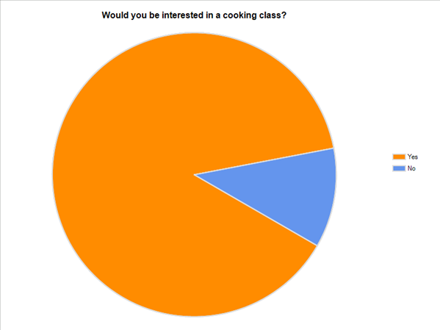

Graph 1. Cooking Class Interest Level

As the grade level increased from freshmen to seniors, fewer students responded to our survey. Of those interested, 31.0% were freshman, 27.7% were sophomores, 22.7% were juniors, and 18.6% were seniors. However, we believe that this is because upperclassmen are less likely to respond to email surveys. We know that because of the people who responded, the percent interested only declined slightly, while remaining above 80% in all cases. 93.3% of the freshmen who responded to the survey were interested, while only 82.2% seniors who responded were interested.

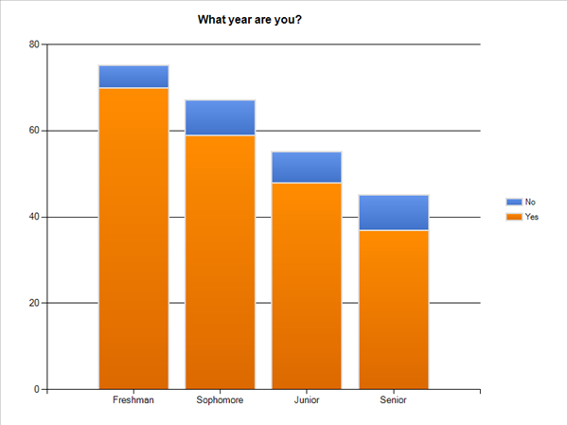

Graph 2. Cross-tab Analysis of Interest vs. Undergraduate Year.

80.1% of those surveyed said they would be interested if offered PE credit. 50.2% of those interested said they already completed their PE requirements. However, 87.1% of those who completed their PE requirements would still be interested in taking this course.

Of the seniors who responded to the survey, 82.2% said they would be interested in a cooking class, and 75.6% said they would be interested if they received PE credit. Therefore, even though the seniors have the least amount of interest out of the four grades, they are still very supportive of the program and having the program offer PE credit.

Graph 3 shows that students who both students who have and have not completed their PE requirements would be interested in the class if they received PE credit.

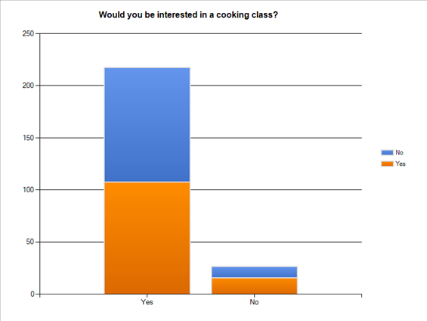

Have you completed your PE requirement?

Graph 3. Interest Level in Students Who Have Completed Their PE Requirements

69.8% of those who are responded and are interested are not Greek-affiliated, as seen in Graph 4. This is likely because the Greek houses have a chef who cooks dinner every night. These houses include 4/6 of the sororities, and probably includes about 22/25 fraternities. Almost every affiliated non-freshman male lives at his fraternity house and most freshmen boys spend every day there. For the sororities, not as many sisters live in the house, but they are allowed to go there for dinner whenever they want to. There is a high interest for non-Greeks because they have to fend for themselves in terms of food. Some of the fraternities even provide lunch every day, and all houses have staple breakfast and lunch foods like cereal, eggs, milk, yogurt, bread, cold cuts, etc. This is also probably why more females are interested in the program than males, as shown in Graph 3.



Graph 4. Greek-affiliated vs. Non-Greek Affiliated Interest in Cooking Class

Far more females than males responded to the survey. Of the 218 respondents, 188 were female. This shows a strong desire from females for the program. However, of the males that responded, 93.1% of them were in favor of a program.

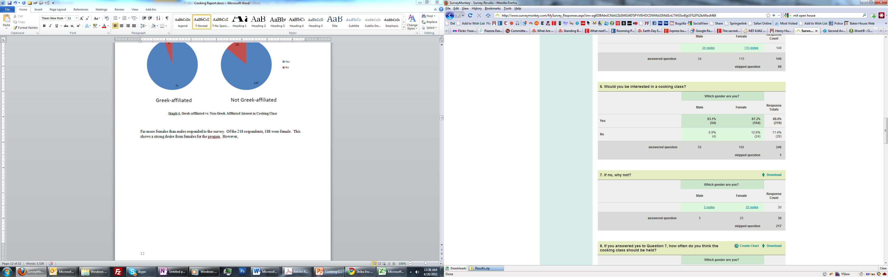

Graph 5. Cross-tab Analysis of Interest vs. Gender

Even if the course were required a fee, 83.5% of the students would be willing to pay. They understand that this would be fair because they would be allowed to eat the meals after.

Our data clearly shows that students will be interested in cooking classes. Further details, such as preferred locations, curriculum, and frequency of classes, will be presented later in the paper.

## Staffing

Given that over 80% of the 246 respondents are interested in a cooking class, we assume this popularity roughly mirrors the big MIT population. That is, if cooking classes are offered, there would enough student interest to meet attendance requirements.

We proceed to propose details of these classes. In terms of staffing, there are multiple options for the teaching position of the cooking classes, each with its pros and cons.

1. Hire professional chefs or culinary instructors as part-time teachers. This strategy would work especially well for professionals who have on-and-off days, or if students prefer a time in the evening or on non-work days. Similar systems have proven to be successful with the MIT PE instructors. However, the downside is the heavy cost to hire these instructors.
2. Bring the chefs currently on campus, whether in dining halls or school cafes. This approach might enable us to collaborate with the MIT Committee on Dining to reach a low-cost, highly efficient agreement. In particular, for our short-term pilot program, one option is to ask for chef volunteers. The pro is the elimination of costs associated with staffing all together, while the con is the inability to sustain such a program for a long period of time.
3. Depending on student interest, we could also hire student volunteers. There are many talented student cooks on campus who would be more than willing to share their knowledge and skills. Their participation could potentially increase further if they get paid. The negative side of this option is that students have time limitations that may cause unpredictable absences, making it harder to run the program smoothly.
4. Invite specific chefs from local restaurants based on student requests. For example, students who enjoy food from Thailand Café might have particular requests about how to make one or two dishes. This way, the students get to sample a wide range of cuisines and focus on their favorite dishes; meanwhile the restaurants increase their publicity and popularity among students. But with this option, we have no guaranteed collaboration from restaurants, since they do have to sacrifice both time and money to support such a program.

After considering all four options, the CCC recommends option 2. Because of the conservative and careful mindset of the school, a pilot program would be much more appealing to school officials than a long-term program that may not may not be feasible. And for such a program of shorter time period, the lower the cost, the better. Option 2 recommends using volunteers from current school chefs, reducing staffing cost to zero. In fact, Bon Appetite has already expressed interest for collaboration by sending chef volunteers, proving the option’s feasibility.

Curriculum  
The content of the proposed cooking classes depends highly on student preferences, which could be determined by survey instruments and field interviews.

In our survey, we focused on the level of hardship of these cooking classes. 52.3% said they would be interested in intermediate-level cooking courses. The others are evenly split between beginner and advanced courses. Thus, our focus should be intermediate courses, as shown in the graph below.

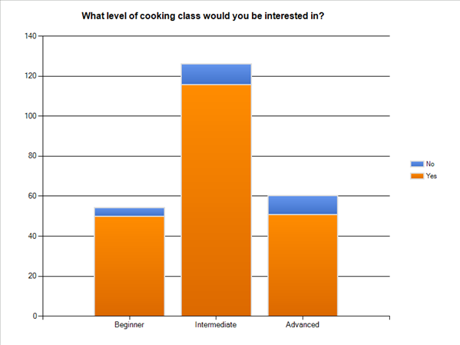

In general, the material taught could be divided into two categories: food safety and culinary arts.

1. Food safety. This is a major concern that came up when we talked to Richard (Director of Campus Dining). This category includes product identification for both raw food material and kitchenware, how to handle the food, how long can you keep your food with and without a refrigerator, how to use the equipment in the kitchen. The safety in serving the food is also important, so topics include what time and temperature is appropriate to serve to students, how to safety serve the food, etc. The familiarity with kitchenware is vital; in fact, Richard suggested issuing a certificate once completing this course, and the certificate guarantees the student’s ability to use the common kitchens. The downside of this option is the possible lack of student interest: most students are eager to start making food rather than going through introductory lessons.
2. Culinary arts. The dishes taught should be within the limitations of the available kitchenware in student dorms. This ensures that the students can actually apply what they learned in class to daily cooking. The basic level classes would focus on dishes that are relatively simple to make. The materials required should also be easily collectable. At a medium level, students may request specific food types and cuisines, increasing the possible variety of dishes. And the only restriction to these classes is the school’s approval: for example, Richard believes students should not be allowed to cook until they own the kitchenware certificate.

Finally, if enough students have intentions of further pursuing the art of cooking, we could work with MIT to create an official and professional class similar to those offered by culinary schools. Given the cross-registration available with Harvard and Wellesley, this class could host students from all three populations.

As for the pilot program CCC is proposing, we recommend combining category 1 and 2 into the same program. In other words, at the beginner level, students would start by learning to how to safely identify and serve food, how to use and clean kitchenware, as well as some simple dishes. Entering the intermediate level, students are expected to be familiar with the basics of cooking, and courses would focus instead on specific dish making.

Time

Cooking classes can be of various length and depth. In terms of time, the program could be set up as long-term, short-term, or one-time session. For long-term, the class would run through the entire semester; short-time encompasses a few weeks; and one-time would be a single session lasting a couple of hours.

In order to finish the coursework described in the Curriculum section, we recommend at least 6 sessions, each being about 2 hours long.

Next, we used survey to gather student opinions about the frequency of these classes. Of those who are interested in the cooking class, 77.8% believe the class should be held once a week. The graph below clearly shows that this class should not be held too often.

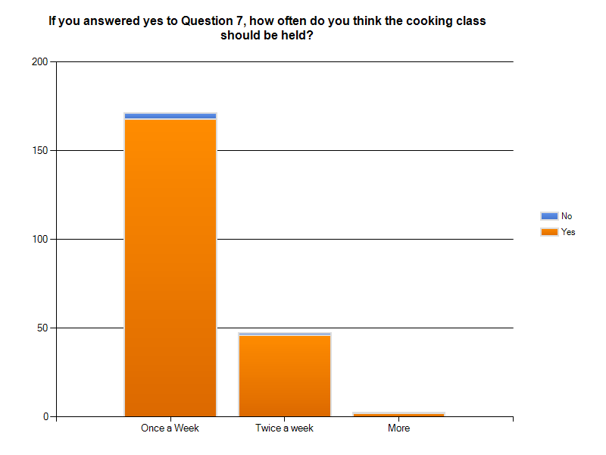

The length of the class also depends on when it is held. Classes can be held during IAP or during the semester. While IAP is a great time for a concentrated class, some students are not on campus. However, during the semester students have many other commitments which makes it hard for many students to commit to attending class frequently.

However, our survey responded very positively to a class during IAP. Over 94% of responded were willing to take a class during IAP.

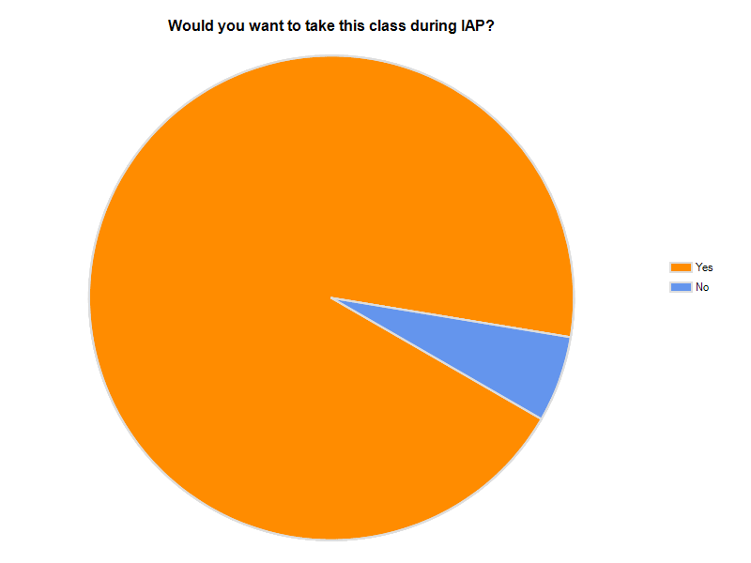

In light of these statistics, we recommend a class during IAP.

During IAP, students have significantly more time to take classes. Thus we recommend a slightly extended, 8 session class, spread twice a week over the 4 weeks, 2 hours per session.

We believe that there is also significant demand during the semester for cooking classes. If the classes would be offered more than once, we recommend adding classes during the semester. During the semester, our recommendation is to have 6 sessions, each 2 hours long, over a span of 6 weeks. This would allow a quarterly schedule, similar to that of PE classes, where students have the freedom to choose the first or second half of a semester to attend these courses.

## Location

Through the use of survey data, an approximate number of students interested in a cooking class has been determined, as well as relevant information such as their current housing placement, their year, whether they are affiliated with a Greek organization, and the status of the physical education requirements. While these numbers are only rough estimates, an initially interested 217 students out of 245 survey takers leads to many considerations regarding the location of a cooking class and the implementation of the class itself.

Since this class is the pilot version of a permanently established class in the future, there is flexibility to try different approaches without large expenditures. Through the location of this pilot class, we hope to answer a number of questions that will help us make the best possible decisions with regard to a permanent class.

The biggest location considerations are the following: accessibility to students; permanence; availability; current use patterns; and size.

### Considerations

#### Accessibility to students

The chosen location must be accessible to the students that are interested in the program. According to Graph 1, 126 and 128 students desired a cooking class to be held in McCormick or Maseeh Hall, respectively. There are more survey takers preferring these locations that live in other locations as compared with those that do live in either McCormick or the Phoenix Group (future residents of Maseeh), which erases some of the bias of residents. With this data and through additional comments, we generally see the desire for the class to be held in a central location to campus. With the question on the survey of where to hold the class, there are a number of confounding variables, such as student judgment of the quality of the facility as opposed to strict distance alone. This is why there are a large number of students that prefer Pritchett, despite 86% of survey takers not living in a dormitory near the facility. However, even with dormitories with industrial kitchens, those that were on the outskirts of campus received few votes, such as Simmons with 34 votes and Next House with 55 votes.

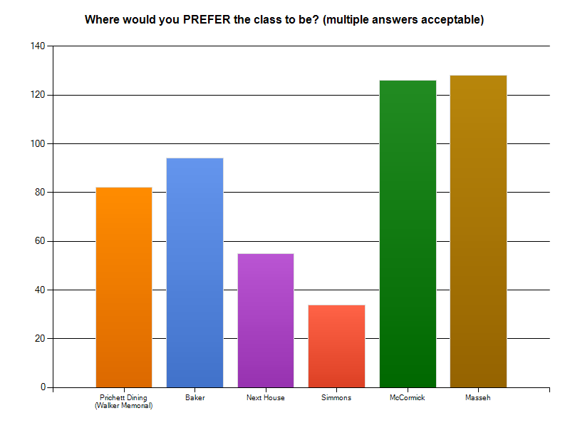Graph 1. Preferred Locations on Campus for a Cooking Class to be Held

#### Permanence

While this may be an odd thing to consider on an established campus, it is necessary to note that renovations occur over time, and we would not want to pilot a class in a location that we could not potentially consider for a permanent class. We will look at the most popular options which are Maseeh, McCormick, Baker, and Pritchett. McCormick and Baker are both established dormitories that were built in the more recent decades of MIT, and will be unlikely to undergo major renovations that would affect a permanent class in the future. Maseeh is a brand new dorm opening in Fall 2011, so renovations of a large kind are highly unlikely. In the case of Pritchett, however, which is inside the Walker Memorial Building, a large renovation is currently being discussed for the following year. This a compelling reason to not pilot the class in this location despite its relatively appropriate facility, because it will be unlikely to exist in the future (Walker is talked about being renovated as a performing arts center). However, it would not hurt to take part in the discussions of the future of Walker Memorial, in the case that the class can be part of the considerations on whether to renovate all parts of Walker.

#### Availability

Although details for the pilot class of not finalized, timing is an important consideration. The location we choose must be appropriate for the audiences we are targeting. Since the most popular options are all dormitories, we must take note of limitations. The industrial kitchens in McCormick and Baker are on a similar use schedule: they would be unavailable during dinner hours Sunday-Thursday, and probably a few hours before due to dinnertime preparation. In the case of Maseeh, which will serve breakfast, lunch, and dinner, the industrial kitchen would not be available at all Sunday-Thursday, except perhaps during the late evening hours. According to the data in Graph 2, 78% of students are in favor of a class that meets once a week, and a Friday or Saturday class would be a possibility given current constraints on the preferred locations.

#### Current Use Patterns

While this is not an issue in the above mentioned locations, as the industrial kitchens have no official use after dining hours, it would be an issue when considering other locations not asked about in this survey. Whether or not other students or student groups use the space on a daily or event based basis would need to be a consideration for a consistent class, as there is a possibility of displacing these groups.

#### Size

89% of the students taking this survey are in favor of a campus wide cooking class-this is over 215 students. While this is not necessarily the number of students that would actually show up for such a class, it illustrates that there is significant interest. There will never be a space this large, and the space limitations of the final location chosen will limit the number of students that can actually attend. Maseeh, having the only industrial kitchen that will be serving breakfast, lunch, and dinner, is likely to have the largest capacity for a pilot cooking class. McCormick and Baker will large, but smaller, given the fact that the dorms themselves are smaller and they are only serving one meal each day.

### Alternative Locations

Other alternative locations that were not options in the survey include a space in the student center and dormitory floor kitchens (not industrial kitchens). Dormitory floor kitchens would face competition from the residents of that dormitory that may be trying to use that kitchen, but there is much more overall freedom in their availability. The other option would be a minor renovation to a student center space, in which we specifically recommend the Coffee House Lounge (not in use as an actual coffee house).

#### Coffee House Lounge

As a result of proven success by student groups that the coffeehouse could be a social atmosphere, the Coffee House was adopted as a reservable event space by the Campus Facilities Complex (CAC), and is now used by a variety of student groups and MIT faculty and staff members. Tare a number of consistent users of the coffeehouse. SaveTFP continues to use the coffee house for their weekly, Friday night events; Coffee Talk uses the coffee house as a relaxing environment on Wednesday evenings to let people drop by for free coffee and biscotti and to chat with old and new friends; and Live Music Connection (LMC) uses the coffee house as a concert space because of its intimate size and appropriate acoustics. Other groups reserve the space for one-time events when it is available.

Currently, the coffeehouse has the following features behind a locked accordion door (opened upon reservation of the space): a large display case (it previously held food items), two sinks, ample counter space, a storage pantry, a speaker system and plenty of electrical outlets. The rest of the event space includes a microwave, a vending machine, couches, plenty of tables with chairs, and an AV cabinet to control the pull-down projection screen. All of these features are used by the variety of groups that use the space – the room is used as both a study and group meeting space when the room is not reserved, due to the abundance of couches and tables and chairs; groups use the sinks to wash cups and other supplies used when food is served; the microwave is used by individuals to heat up food, or by groups to pop popcorn or serve microwaveable food; the speakers are used during events; and the projection screen is used for movie screenings and presentations.

With the addition of a series of stoves where there currently exists counter space, the space could be modified for wider usage by its current audiences, and for new audiences such as a cooking class. The stove tops would still serve as space for existing groups, but open up new opportunities for the space to be used for cooking classes of increased frequency over time, or for student groups.

## PE Credit

In our survey, over 80% of students said they would be interested in the class, if they could receive PE credit. Undergraduates at MIT must earn 8 PE points in order to graduate. Students can currently earn PE points in multiple ways:

* PE Class – 2 points per class
* Varsity Athletics – Up to 4 points a year
* ROTC – 2 points per year, 4 maximum
* Personal Training Sessions – 2 points for 440 minutes
* Group Exercise Classes – 2 points for 440 minutes

Many students take PE classes in order to earn PE credit. The Department Of Athletics, Physical Education & Recreation currently has over 30 classes on file, with about 15 offered every quarter. Most classes currently center on a particular sport or activity, such as Golf, Archery, or Sailing. However, some of the more recent classes, such as “Upgrade Your Health and Happiness,” also cover topics such as nutrition and health.

Students were interested in earning PE credit so that they could fulfill one of the graduation requirements for MIT while learning something interesting and helpful. Earning PE credit for taking the cooking classes would allow them to take cooking classes instead of another topic they are less interested in.

We also feel that PE credit would dedicate students to completing the entire cooking class. This would enhance the educational experience of the class. In addition, the program could be partially funded by the money set aside for PE classes.

On 4/14/2011 one of our team members met with Carrie Sampson Moore, the Director of Physical Education at the Department Of Athletics, Physical Education & Recreation to discuss the requirements of receiving physical education credit. In order to receive PE credit the class would have to include an active recreation component. This could be included in some classes, for example, walking to Shaw’s for a class in product identification. In order to qualify for PE credit, the class would require at least 30 minutes of physical activity, twice a week, at minimum. The Department Of Athletics, Physical Education & Recreation would provide the instructor for the active recreation component. This would constitute the extent of the Department’s contribution of resources for the class.

However, except for walking to Shaw’s, the active recreation cannot be included seamlessly with the class. Since a typical PE class is 1 hour, twice week, this would take up half of the instruction time or require the class to be longer than a typical PE class. We feel that because the active recreation component of the class would be poorly integrated, it is not worth seeking PE credit for the cooking class.

## Cost

## Conclusion

We believe that there exists sufficient interest in a cooking class, that a program be piloted at MIT. Furthermore, we believe that the program is feasible at many different levels. There is a tradeoff between the formalness of the program and the required investment. Many other programs at MIT have a dedicated space and instructor/maintainer. These programs have built up a deep history at MIT and have served many students while they were here. We see that potential for a cooking class as well.

Despite the overwhelming interest, however, we believe that a test program be established first before significant investments are made. This test program could be operated with volunteer chefs, provided by one of the current dining vendor on campus. Vendors are willing to volunteer because they are trying to build up good will with the campus community. The class should start by teaching safety procedures and then cover intermediate techniques. If the class is only being offered once a year, IAP is the best time to offer it. During the semester, the class would be best offered one evening a week for 6 weeks. The Next House student kitchen is the best place to hold the pilot program because of its size. Other places are now possible due to a variety of reasons. It is not feasible to offer PE credit because the PE program requires active recreation which is hard to fit into this program. The program’s cost will be minimal and can be covered by charging a participant fee. Students feel this is fair since they get to eat the food afterwards.

We feel that offering cooking classes will help MIT help students learn to eat healthy and nutritiously.

## Appendix A: East Campus Cooking Class Advertisement

As in the past, it's a six-week class that will teach you the basics of cooking. It's taught by Victoria Davenport, Dean Colombo's Senior Administrative Assistant and a former professional chef. She focuses on meals that are cheap and quick to make, and also teaches how to shop for food, how to examine produce, and general cooking principals.

The class is happy to accept those will food allergies and vegetarians, but unfortunately the class cannot be adapted for vegans.

The class will run Wednesday nights: 6-7pm April 6, and 6-8pm April 13, 20, 27, and May 4, 11. It will be held in one of the EC kitchens.

You will be given a list or ingredients for each week (except the first week), and you will be responsible for shopping for these ingredients and bringing them to class. You are responsible for paying for food, but it will be partially subsidized by [EC] DiningComm, so the cost will be no more than $5 per week, and possibly lower.

## Appendix B: Survey

#### 1. Which gender are you?

|  |
| --- |
| https://www.surveymonkey.com/i/t.gifMale  https://www.surveymonkey.com/i/t.gifFemale |

#### 2. What year are you?

|  |
| --- |
| https://www.surveymonkey.com/i/t.gifFreshman  https://www.surveymonkey.com/i/t.gifSophomore  https://www.surveymonkey.com/i/t.gifJunior  https://www.surveymonkey.com/i/t.gifSenior |

#### 3. Are you Greek-affiliated?

|  |
| --- |
| https://www.surveymonkey.com/i/t.gifYes  https://www.surveymonkey.com/i/t.gifNo |

#### 4. Where do you live?

* Baker
* Bexley
* Burton Connor
* East Campus
* MacGregor
* McCormick
* New House
* Next House
* Random Hall
* Senior House
* Simmons Hall
* FSILG
* Off-Campus

#### 5. Which club(s) are you in (if any)?



#### 6. Would you be interested in a cooking class?

|  |
| --- |
| https://www.surveymonkey.com/i/t.gifYes  https://www.surveymonkey.com/i/t.gifNo |

#### 7. If no, why not?



#### 8. If you answered yes to Question 7, how often do you think the cooking class should be held?

|  |
| --- |
| https://www.surveymonkey.com/i/t.gifOnce a Week  https://www.surveymonkey.com/i/t.gifTwice a week  https://www.surveymonkey.com/i/t.gifMore |

#### 9. Would you want to take this class during IAP?

|  |
| --- |
| https://www.surveymonkey.com/i/t.gifYes  https://www.surveymonkey.com/i/t.gifNo |

#### 10. Would you be interested in the class if you received PE credit?

|  |
| --- |
| https://www.surveymonkey.com/i/t.gifYes  https://www.surveymonkey.com/i/t.gifNo |

#### 11. Have you completed your PE requirements?

|  |
| --- |
| https://www.surveymonkey.com/i/t.gifYes  https://www.surveymonkey.com/i/t.gifNo |

#### 12. Do you cook?

|  | **Never** |  | **Sometimes** |  | **Very Often** |
| --- | --- | --- | --- | --- | --- |
|  | https://www.surveymonkey.com/i/t.gif | https://www.surveymonkey.com/i/t.gif | https://www.surveymonkey.com/i/t.gif | https://www.surveymonkey.com/i/t.gif | https://www.surveymonkey.com/i/t.gif |

#### 13. What level of cooking class would you be interested in?

|  |
| --- |
| https://www.surveymonkey.com/i/t.gifBeginner  https://www.surveymonkey.com/i/t.gifIntermediate  https://www.surveymonkey.com/i/t.gifAdvanced |

#### 14. Would you be willing to pay for a materials fee (given that you get to eat the food after class)?

|  |
| --- |
| https://www.surveymonkey.com/i/t.gifYes  https://www.surveymonkey.com/i/t.gifNo |

#### 15. Where would you PREFER the class to be? (multiple answers acceptable)

|  |
| --- |
| https://www.surveymonkey.com/i/t.gifPrichett Dining (Walker Memorial)  https://www.surveymonkey.com/i/t.gifBaker  https://www.surveymonkey.com/i/t.gifNext House  https://www.surveymonkey.com/i/t.gifSimmons  https://www.surveymonkey.com/i/t.gifMcCormick  https://www.surveymonkey.com/i/t.gifMasseh |
| Other (please specify) |

#### 16. Please provide any additional comments:



## Appendix C: Requirements for a PE Class

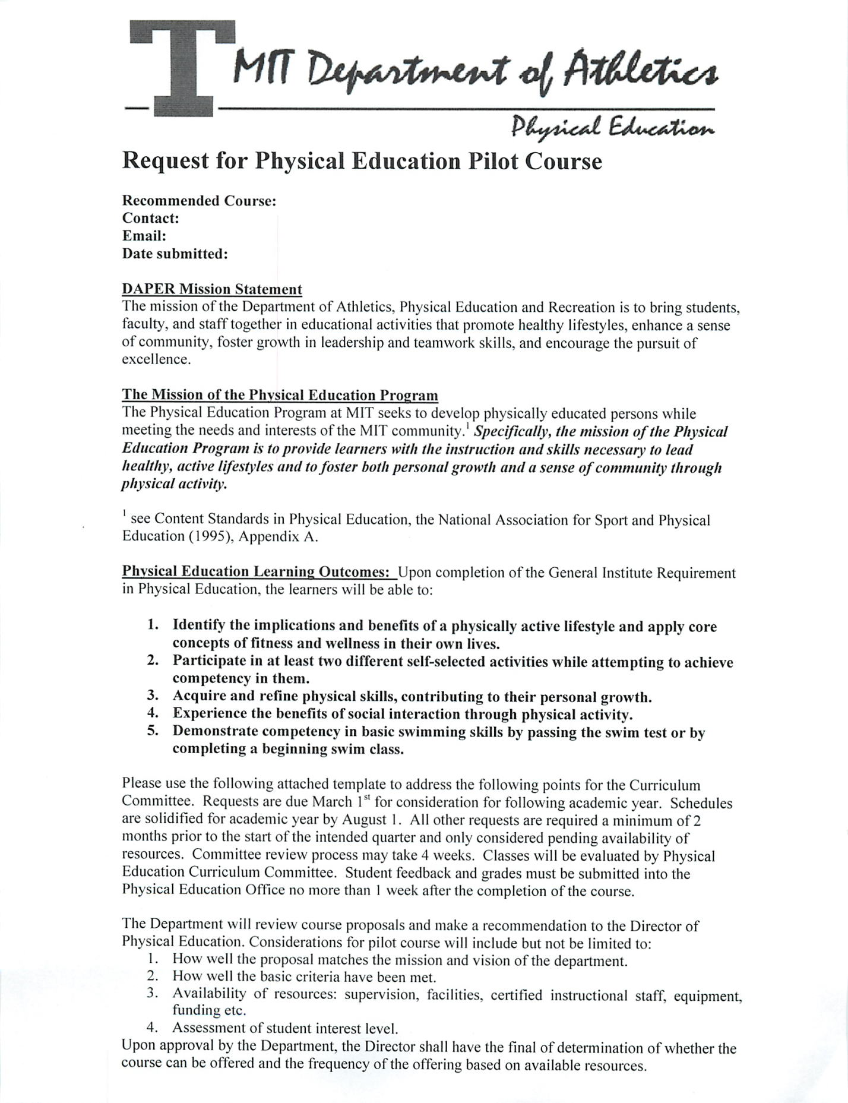

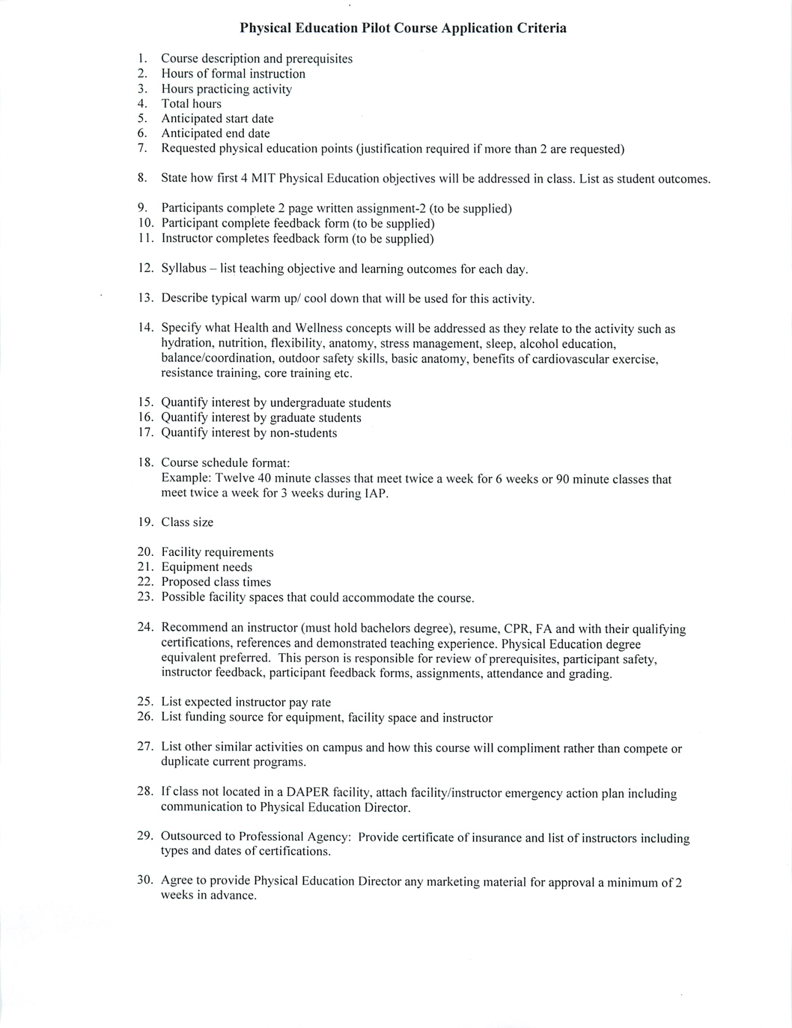

## Appendix D: Draft Class Plan from PE Department

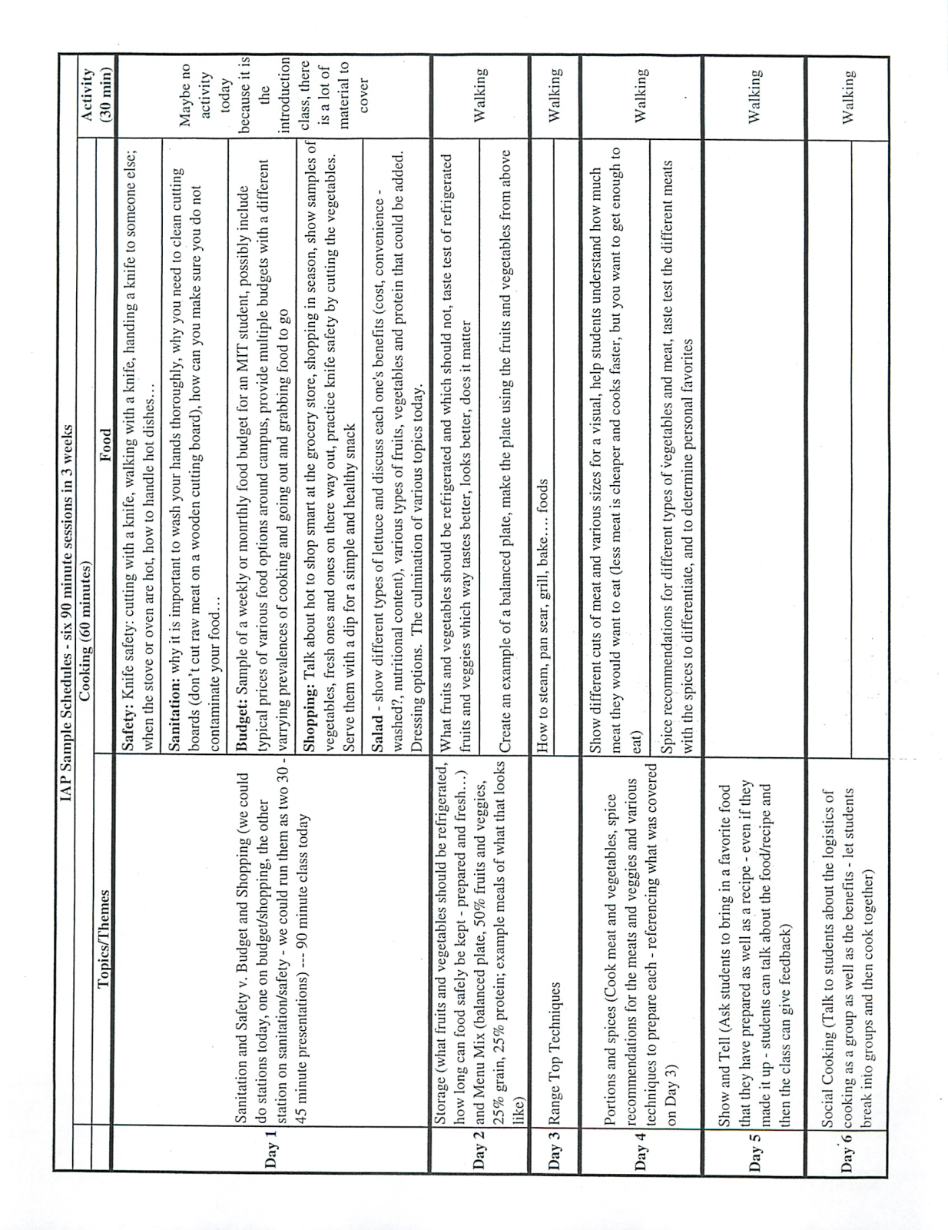

## Appendix E: Survey Results

