Name:Michael Plasmeier

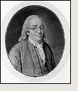  Name: | State Represented:
 | Age during the Constitutional Convention:
 | Government/Political Experience (2 highest positions): A representative to the General Assembly of Pennsylvannia; Post Master General of America
 | Military Experience: Yes No If yes…Highest Rank N/A
 | Fact:
 | Interesting Fact: He established the Universty of Pennsylavannia
 | Legacy: Flying a kite during a lightning storm to prove that lighting was electricty
 | Quote: "A penny saved is a penny earned" -BF
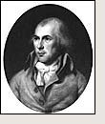  Name: | State Represented:
 | Age during the Constitutional Convention:
 | Government/Political Experience (2 highest positions): 3rd US President; USA House Representative
 | Military Experience: Yes No If yes…Highest Rank N/A
 | Fact:
 | Interesting Fact: His notes are used as the record for the Convention
 | Legacy: Being the 3rd USA President, notes during Constitutional Convention
 | Quote: "All men having power ought to be distrusted to a certain degree." -JM
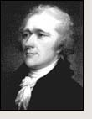  Name: | State Represented:
 | Age during the Constitutional Convention:
 | Government/Political Experience (2 highest positions): Secretary of the Treasury;
 | Military Experience: Yes No If yes…Highest Rank Colonel
 | Fact:
 | Interesting Fact: He was born an illegitimate child, and his family was not well off.
 | Legacy: He helped create the first party system in America, as a Federalist.
 | Quote: "I never expect to see a perfect work from imperfect man." -AH
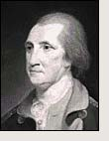  Name: | State Represented:
 | Age during the Constitutional Convention:
 | Government/Political Experience (2 highest positions): ¹st President of USA; leader of Constitutional Convention; surveyor
 | Military Experience: Yes No If yes…Highest Rank General
 | Fact:
 | Interesting Fact: George Washington turned down proposals to take over the government and make him king. He unanimously won the first presidental election in 1788.
 | Legacy: Being the General of the Contental Army during the revolution, and presiding over the Constitutional Convention.
 | Quote: "Every post is honorable in which a man can serve his country." -GW

