Artifacts, Layers, Traces, and Trends
  - Michael Plasmeier
The buildings on my site have been built over many different time periods that are evident in the different buildings styles which reflect the attitudes of the times in which they were built. By tracing these styles and looking at the trends, I found that the development on my site has gone full circle in many regards. In the very beginning, many developers built for many different purposes on small lots. Different uses were integrated right next to one another. However, in the urban renewal drive of the 1960s much of my site was bulldozed. The first part to be rebuilt, Copley Place was designed and built as a monolithic development. When Tent City was developed later, many of the ideas in Copley Place were reverted. For example, city streets were added back to the site in order break up the scale. Much of this can be attributed to Jane Jacob’s book The Death and Life of the Great American City.
In order to find these traces, I took a walk around my site. I started by walking through the oldest part of my site, the original South End homes, from the turn of the century. I then walked through Tent City, the mixed-income housing development of the early 90s before heading through the developments of Copley Place from the 80s.

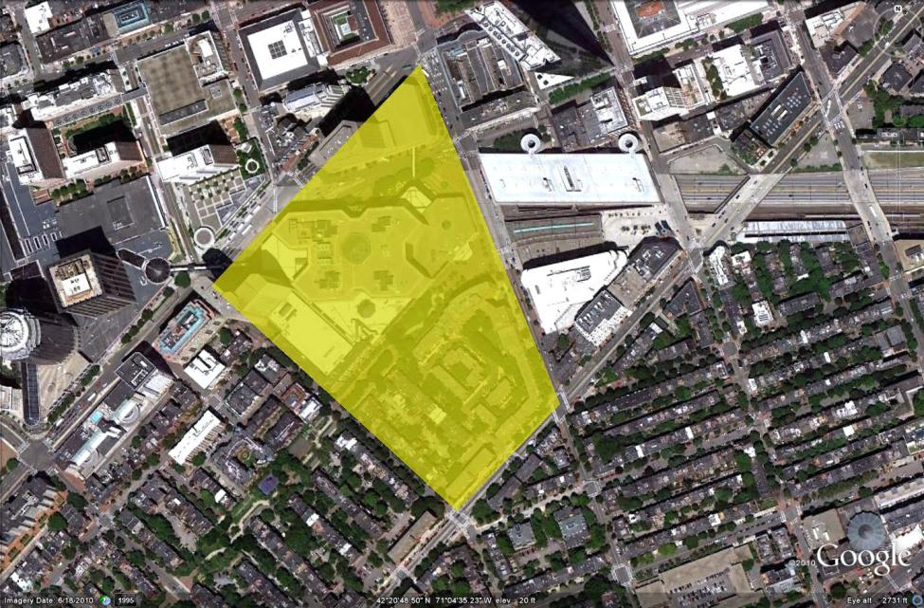

Figure 1 Map of Site from Google Earth
There is one block of original South End homes remaining on my site. These homes all look similar, but are not identical. While I was researching my site, I found that they were built by different builders. All of the homes are built in a similar brick style. Like much of the Back Bay and South End, almost all of the homes have a long main stair that goes up to the first floor. Some of the homes even have a small entry to the basement under the main stairs. This is an artifact of the era when one family lived in the home and the kitchen was in the basement.
The homes were originally built for the wealthy. However, the rush of immigrants to the area soon after the houses were built, pushed the original owners to the Back Bay. These homes were considered to be blighted and part of a slum in the 60s and 1970s. However, as I walked down the street the neighborhood did not look anything like a slum.
The homes do not look run down at all; in fact, they look like they were restored with historical character in mind. The small yards are nicely fenced in, with bars that match the fire escape on the building. The sidewalks are paved with historical brick. The streetlights, although they have a modern light element, have been made to look historical. All of these signs point to the appearance that people live here who care about the historical nature of the site and have the money to pay for improvements.
The houses have come full circle. They once again house the wealthy people that they were designed for.
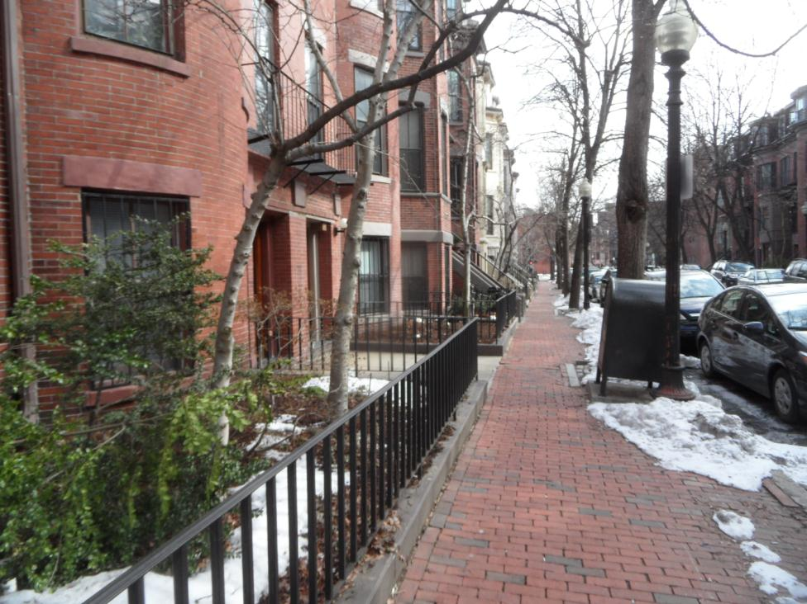
Figure 2 West Canton Street

Around the corner from the high-end South End homes is the Methunion Manor Coop. This is an artifact of when the neighborhood was lower income. The building is very simple in appearance, as if almost no care was put into how the building looked. It seems to have been built at the lowest possible cost. The building continues to provide low-income housing to the neighborhood, and is out of character with the nicer looking homes up the street.
Perhaps some time in the future it will be bought out and replaced by luxury apartments. The neighborhood would then have come full circle, back to accommodating wealthy residents.
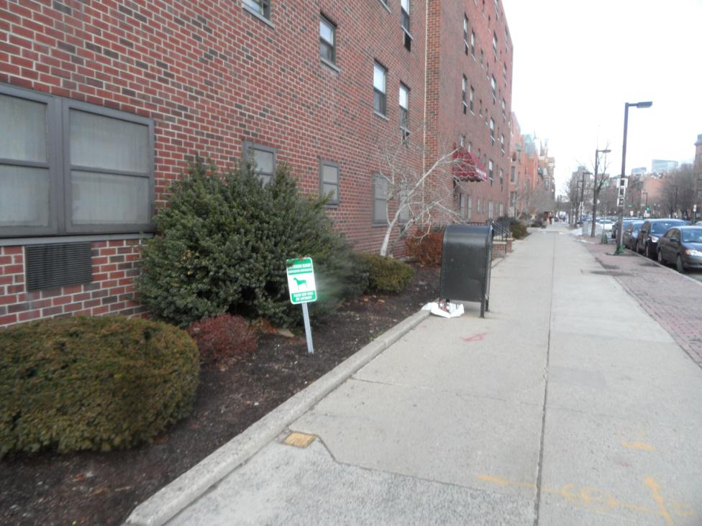
Figure 3 Methunion Manor Co-op along Columbus St

The mural on the side of one of the old South End homes also points to the past history of the neighborhood. It portrays an African American neighborhood; no doubt left over from when many more African Americans lived in the neighborhood. I also noticed that a new dryer outlet seems to have been installed on top of the mural in one place, indicating that the new owners are not going to out of their way to protect the mural. The mural is also starting to fade. I could imagine that in the future, houses are built over the entrance to the alley and the parking lot. A glance at the historical map shows that houses used to extend further towards Columbus Avenue. If housing is once again built here, then this patch of land would have come full circle back to housing.
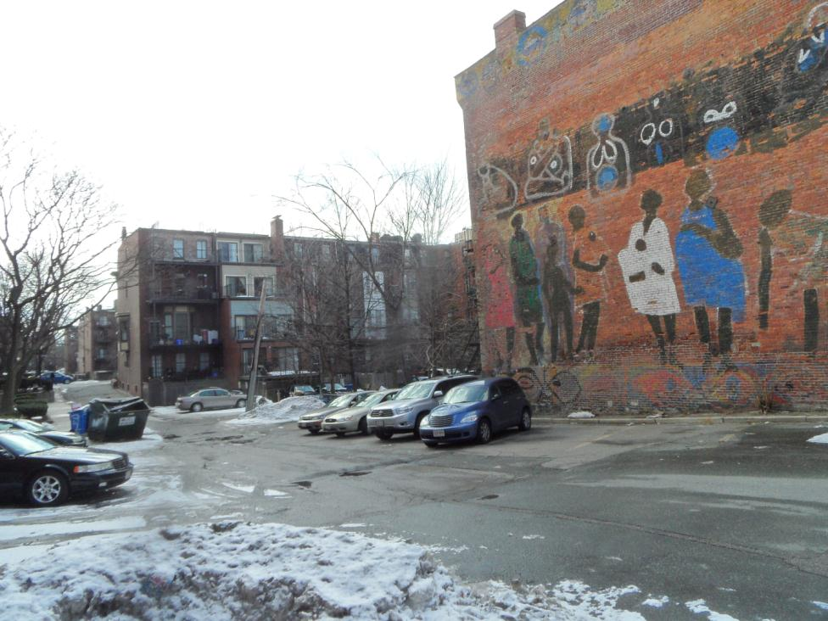
Figure 4 Mural near the corner of Yarmouth and Columbus
Moving across the street to Tent City, I can clearly see that it was built fairly recently. All of the buildings look the same, despite the attempts I read about to make the project fit in to the South End. Tent City, was, of course, all built together in one large project, above a parking garage. The designers tried to replicate the street neighborhood of the South End. They even built the little hole under the stairs to mimic the old buildings.
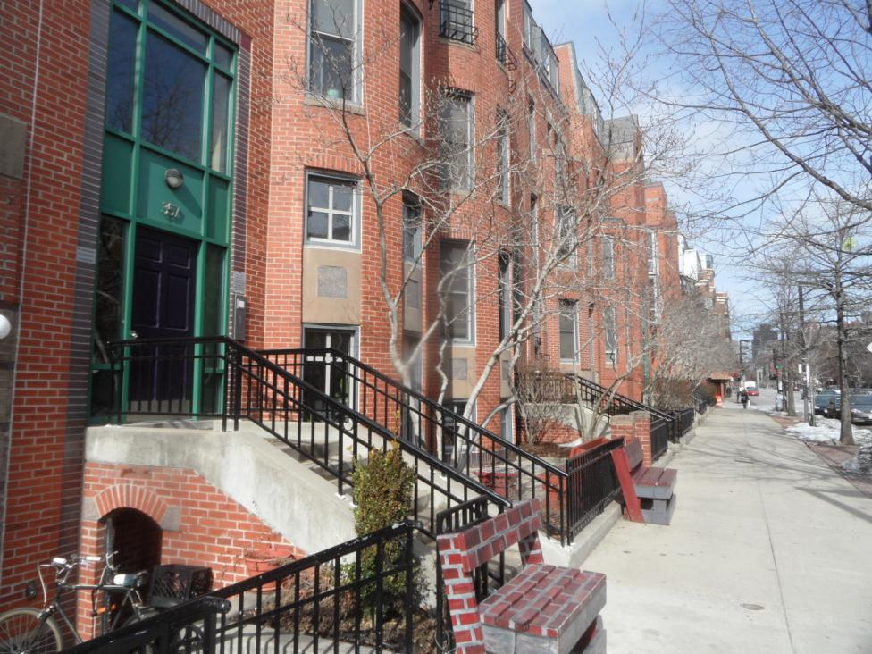
Figure 5 Tent City along Columbus St
I believe that Tent City was a product of Jane Jacob’s The Death and Life of a Great American City. In the book, Jacobs rails against the large-tower public housing that was so popular at the time. She argues for small blocks with sidewalks which residents and shop keeps can observe and monitor the street below. The basic design of Tent City, laid out by the MIT study, meets these criteria. Instead of building a large tower over the entire site, much of the land of Tent City is dedicated to low-rise buildings. Streets were created, where none existed before. The streets are normal city streets, complete with traffic and curb-side parking. The playground at Tent City is inside one of the courtyards, allowing the supervision of children from all apartments, similar to a city street. This represents a full circle return from the planning ideas of the 1960s to the original ideas of how a city should operate.
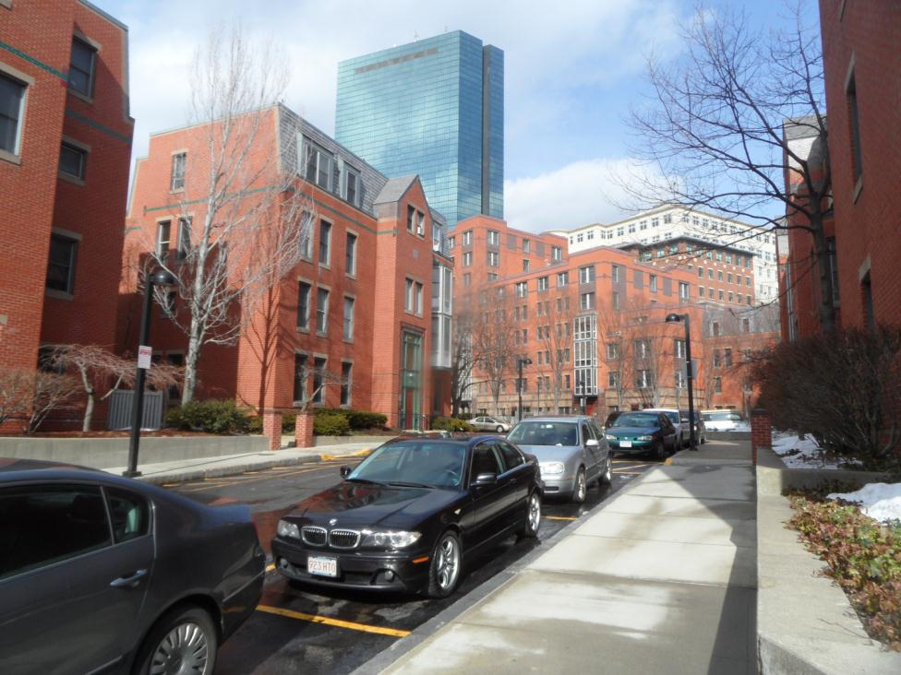
Figure 6 Tent City Low-Rise buildings along Yarmouth Pl
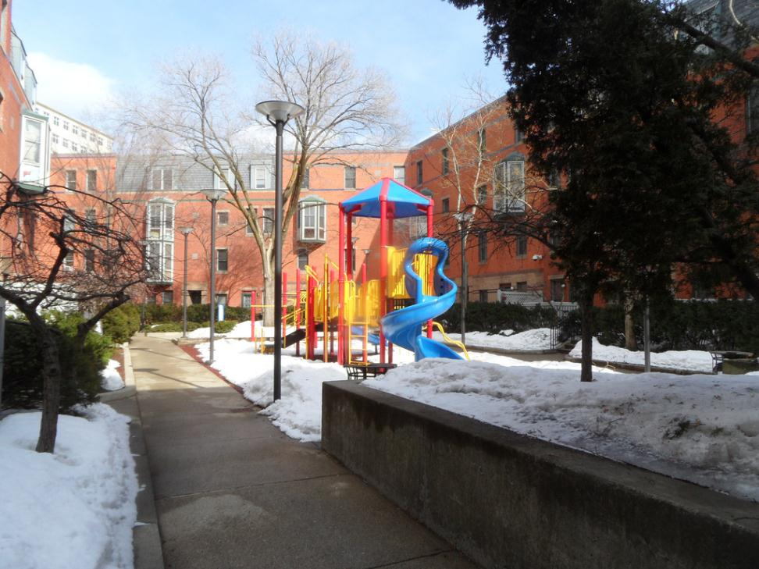
Figure 7 Tent City Playground

Tent City mixes densities. So far, I’ve mostly talked about the low-rise portion of Tent City. However, Tent City also has a mid-rise tower. I remember reading that this was put in place to increase the density of the site and accommodate the elderly and the disabled who need an elevator. Jacobs supports building developments with mixed density.
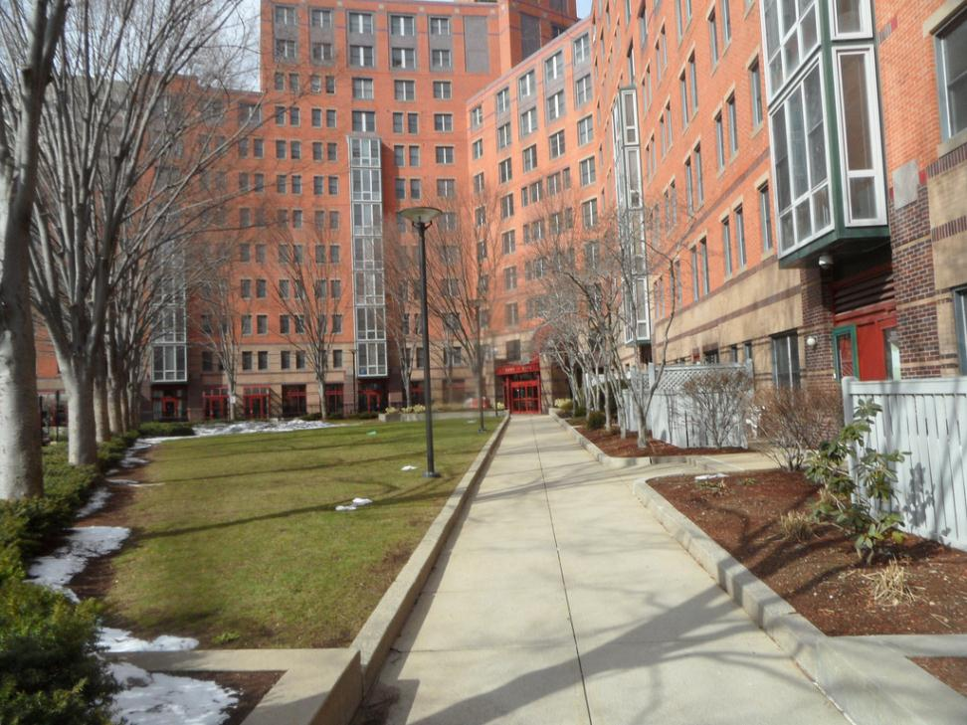
Figure 8 Tent City Mid-Rise Building from Courtyard/Yarmouth Pl
However one recommendation of Jane Jacobs which was not followed, was the need for buildings of a mixed age. When the site was being developed, there were a few original South End houses scattered around the site. However, they were demolished. I think this was because the owners of Copley Place wanted to build an underground parking garage which would have been hard to do while preserving the old homes. The development is mixed income, with the government subsidizing the cost of the monthly rent in order to make it affordable. This represents a full circle return to mixed densities and mixed income housing, which Jacobs found to be more stable than the Modernist housing practices she railed against.
Tent City still followed the traditional idea of focusing on residential, with perhaps a few retail stores on ground level. As I found in my research, the original site was very mixed use with a firehouse, Laundromats, and hotels scattered around the site that now makes up Tent City. Copley Place is actually a better example of how a site can be given over to mixed use; where uses can be cleverly integrated to make use of the available space and diversify the developer’s income.
The development of Tent City still followed a model in between the traditional model and the model Jacobs advocated for. Traditionally, developments were just built by the state or city using public funds. Jacobs advocated for a program now known as Section 8, where eligible individuals get vouchers for buying market housing. Because the original buildings were torn down during the height of the traditional urban renewal period, Jacob’s model would not work. Also, Tent City was built after the period when direct government involvement in construction was frowned upon. So instead, the government gave loans to an organization set up by community members to oversee the construction and operation of Tent City. The development of Tent City was part of the retreat from direct involvement of government in public housing. It was a part of a return to the importance of private landowners, a full circle return from the 1960s.
I cannot pinpoint what it is exactly, but something makes the development look cookie cutter. One specific characteristic stands out from the era when Tent City was actually built: the bright colored doors and pattern encircling the building. Bright purples and blues were very popular in the late 1980s, early 1990s.
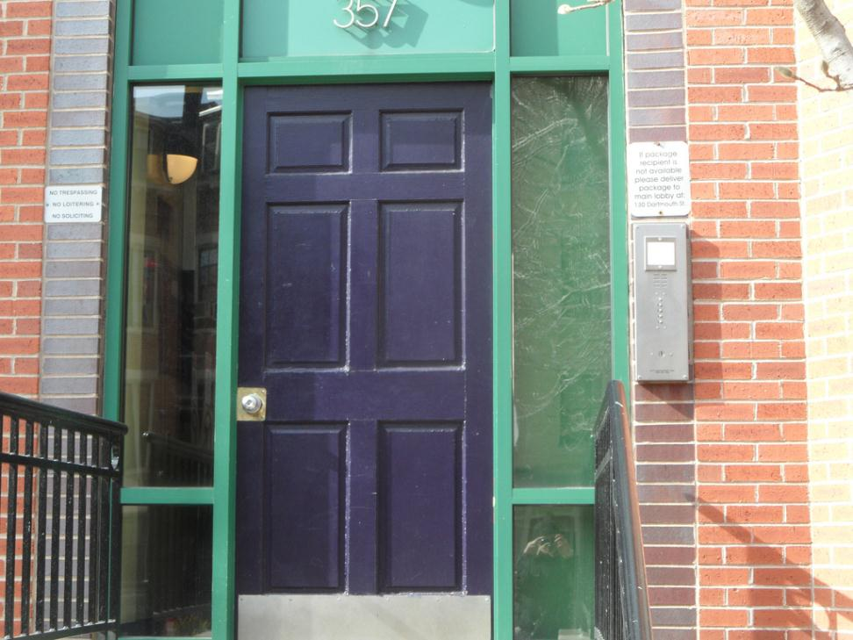
Figure 9 Tent City House Door along Columbus Ave
The signs next to the door look cheaply produced – like a government housing project. I think they could try to use nicer signs. Also the “No loitering” sign seems to be at odds with the desire to create an active street, as described in The Death and Life of Great American Cities by Jane Jacobs.
North of Tent City is the deck over the Southwest Corridor. I noticed immediately that both Copley Place and Tent City have entrances along the deck. This is different from the original buildings because the deck was a fairly recent addition. The railway tracks used to be exposed and, as I read in the Orange Line EIS, were literally “off-the-charts” loud.
The first floor of the Copley Place apartments opens directly onto the street. I never found a reference to this in the planning documents, so it must not have been controversial when it was built. However it does makes the buildings fit in with the neighborhood more. The upper floors are serviced by an elevator that goes directly to a lobby and parking garage, allowing those so residents to avoid interacting with the community. I was surprised to see this in a development of this vintage, but I think street entrances are becoming selling features again luxury apartments; this idea came full circle from the era of long endless walkways with a long walk to the car.
I can also see the shops along the Southwest Corridor in Copley Place. These shops were set aside by the developer for community-oriented shops at below-market rents. However, when I first came to the site, I never noticed the shops. The shops are not noticeable at all if you just walk through Copley Place’s shopping arcade and then exit down the escalator to Dartmouth Street because they face the wrong direction. But even when I was walking along the Southwest Corridor deck, I did not notice the stores. The stores seem to be recessed – primarily because Copley’s main entrance sticks out onto the deck. Also, the main path of the Corridor seems to push people more towards Tent City because of the flower planters on the Copley Place side. I read in one of the minutes of the community meetings that the neighbors were disappointed with the location of the stores. However, the management seems to be trying to promote the stores. There is a sign above them and there was a sign near the entrance to the corridor pointing the stores out.
The stores have a restriction on them so that they can never be commercialized by large chains. Jane Jacobs talked about how neighborhoods can be overrun by chain stores. Because of the restrictions, this is not possible for these stores.
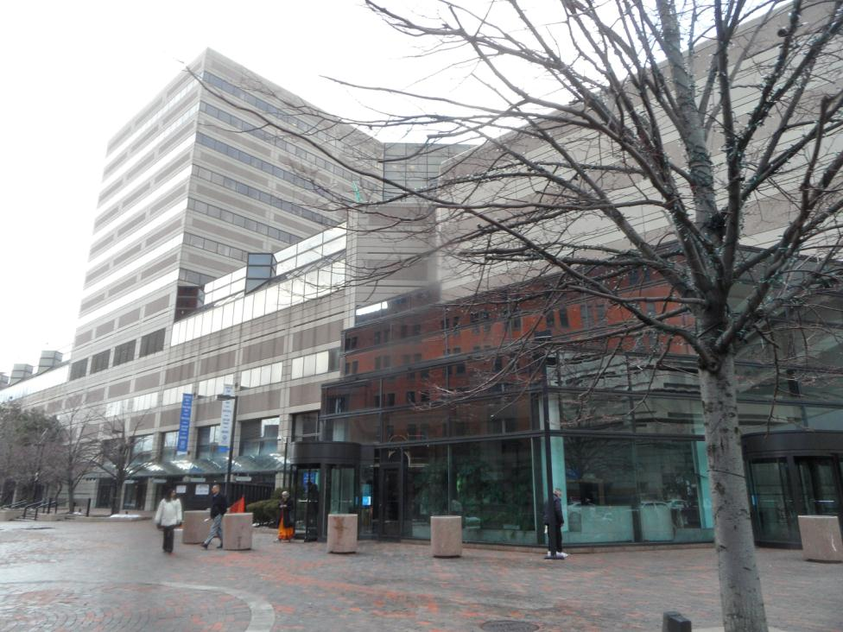
Figure 10 Copley Place at Dartmouth St and the Southwest Corridor
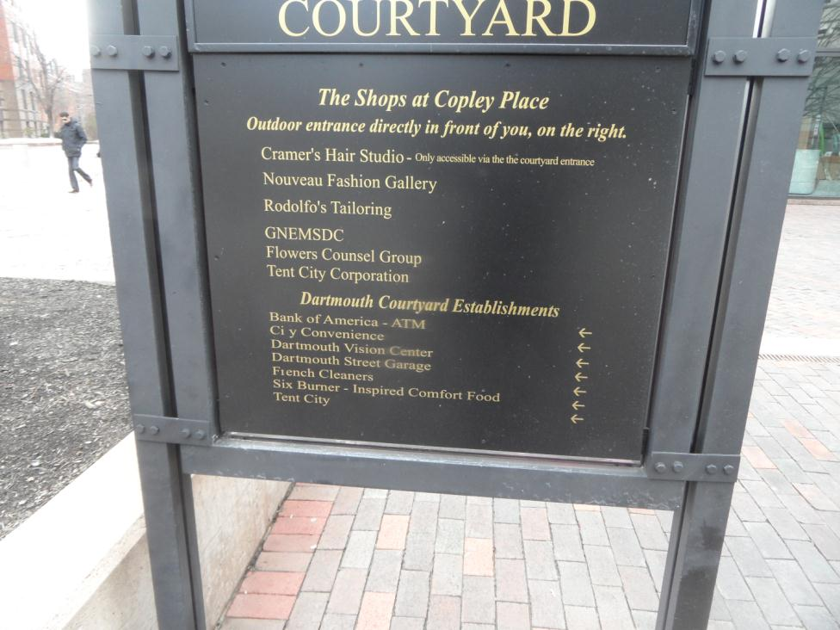
Figure 11 Copley Place Sign at Dartmouth St and the Southwest Corridor
Inside, Copley Place is largely reminiscent of late 1980s large-scale mall-oriented development. This was very popular from the 1960s until the 1980s. However, many malls are now being built outdoors. They are called “lifestyle centers” and they combine high-end stores with carefully landscaped paths and fountains. They are made to look like little villages. Some even have residential units above the store fronts. Suburban Square in Ardmore, PA opened in 1928, but it is attracting national attention today as a model of a “lifestyle center.” This represents a full circle return of retail school of thought back to street-oriented development. It is interesting to realize however that the site never had a connecting street grid because of the railroad tracks.
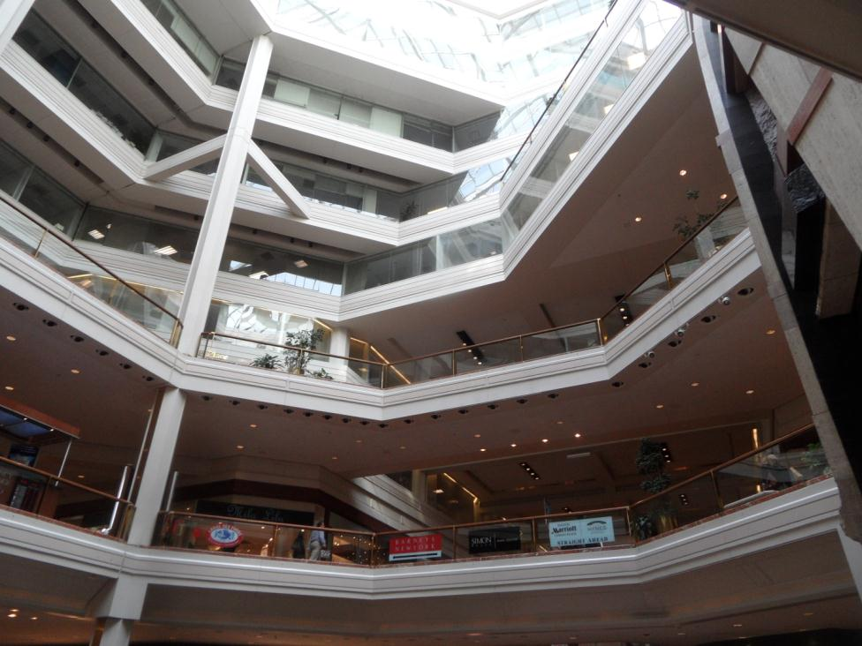
Figure 12 Copley Place Central Atrium
One thing which I learned from studying the plans of Copley Place is that the turnpike is not strictly the reason you go up the escalator to get to the mall, instead you go upstairs to get on top of the parking garage. The builders either could not build the parking garage deep underground because Boston was on filled land, or they did not want to because it would have been too expensive.
A development of this scale certainly felt that it needed parking. Especially when it was built, many commuters drove into the city to work. No tenant would lease that much office space without having a lot of parking available. Some parking was also thought to be needed for the retail. The developers though that shoppers would drive in from the suburbs to shop at the high end stores. The stores reflect this mix – there is no small market where commuters can buy items before heading home. The hotels certainly need parking, as many people drive into the city and expect to be able to park their cars. Urban upscale hotels certainly enjoy charging for parking. I remember that Copley Place was forced to build a garage because no spaces were available in nearby lots and garages.
For many years, municipalities required a minimum number of parking spaces for a given floor area. This was done to make developers provide parking so that the new buildings did not further crowd out street parking. However many cities have now adopted maximum parking rules. Many cities have realized that availability of parking spots creates demand for cars. They have realized that restricting the number of parking spaces encourages transit usage; the return to building a walkable city is another full circle return from earlier schools of thought. For example, MIT in its redevelopment of Kendall Square proposed maximum parking requirements with no minimum required number of spaces. Even a hotel would be limited to a maximum of one parking space for every two rooms. The proposed Copley Place residential tower would add no additional parking, making parking scarser.
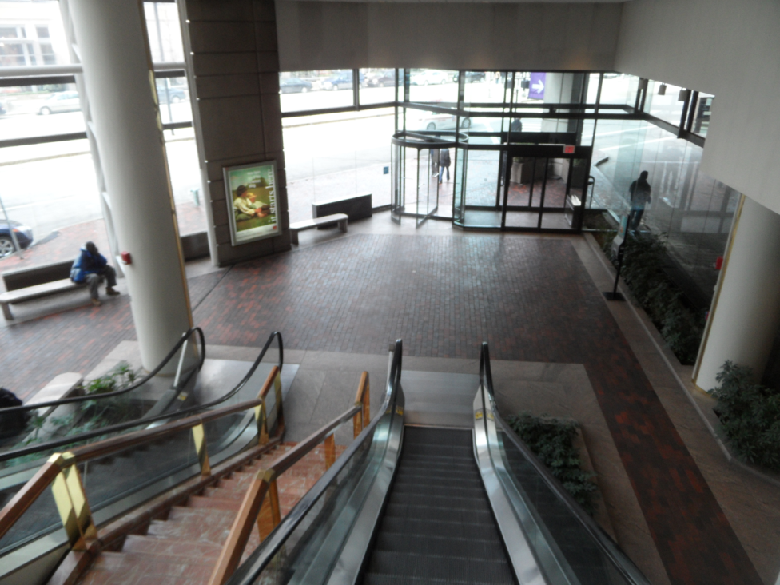
Figure 13 Copley Place Huntington Ave Exit
Another thing I noticed is that there is no direct entrance to the office buildings from outside. If you turn right in the main atrium (when walking from Copley Place) you notice the escalator up to the sky lobby of the office buildings. However, these elevators do not go outside. Some of the newer buildings in Copley Place, like 111 Huntington Ave do have a direct entrance from the outside. An outside entrance seems to be a feature that is being included in newer buildings. This is a full circle return from the mall-era of thought that built Copley Place. I think that people realize once again that walking directly on city streets is not necessarily a bad thing. One does not need a private, enclosed walkway to the parking garage, transit stop, or lunch store.
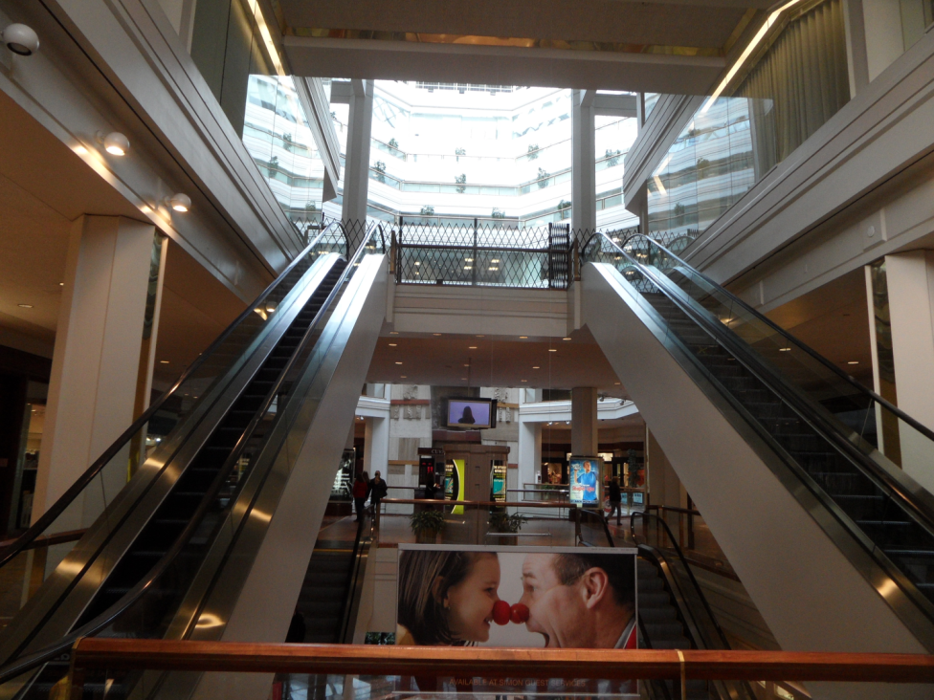
Figure 14 Copley Place Escalators to the Office Sky Lobby

The sidewalk outside of Copley Place is brick, but it feels really corporate. Kendall Square seems the same way. It just feels weird to see the large expanse of perfectly flat bricks in these large scale projects. I can’t decide exactly what it is, but it does not seem right. I think in some cases the desire to feel “authentic” by using perfect bricks over such a large area makes the development feel corporate. I think that good intentions may have made the area feel wrong. In order for the bricks to be perfect, there is probably concrete underneath the bricks.
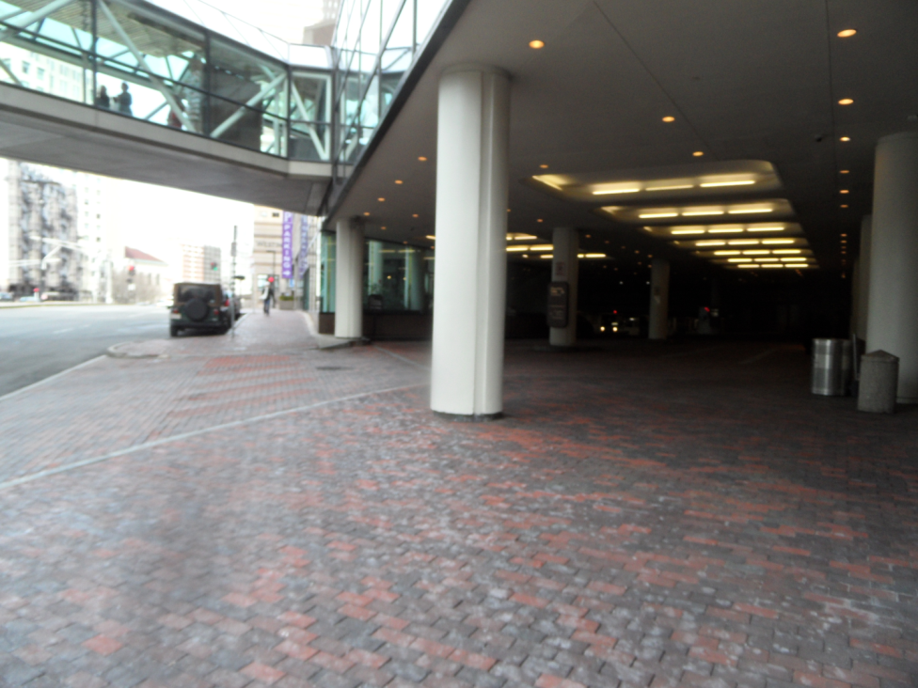
Figure 15 Copley Place Marriott Entrance

Moving over to the Westin, I could tell that there used to be a fountain under the escalators near the entrance to the shopping walkway. However, the fountain was turned into a flower terrace for some reason.
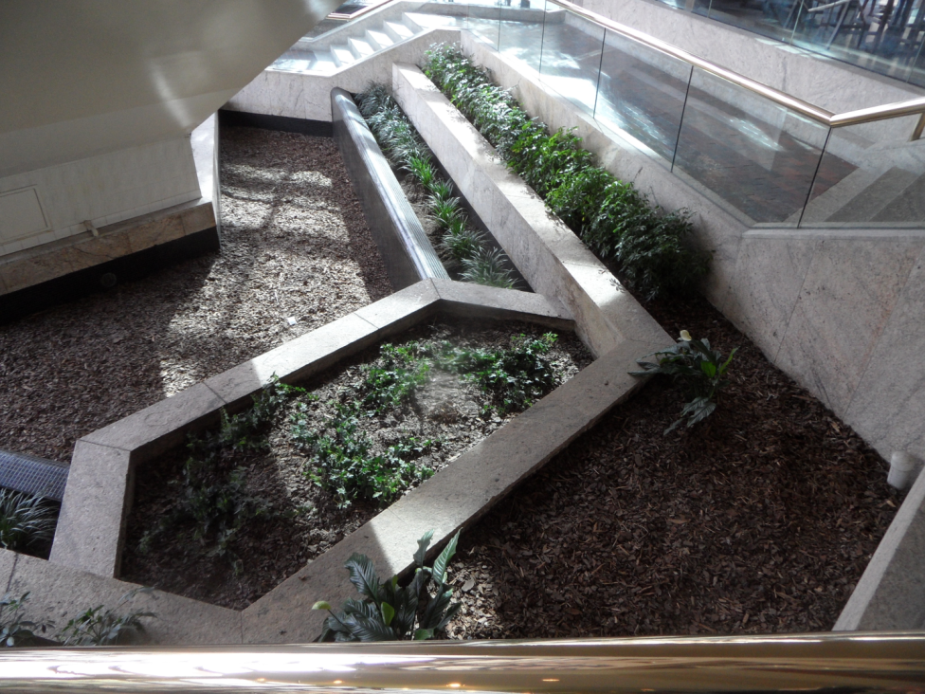
Figure 16 Copley Place Westin Huntington and Dartmouth St Entrance
The marble and gold-colored handrails also look like luxury projects of the 1980s. It reminds me of Trump Tower – but not as bad! New developments have come full circle and do not feel the need to clad everything in gold. I think they have learned that the effect is not as good as they think.
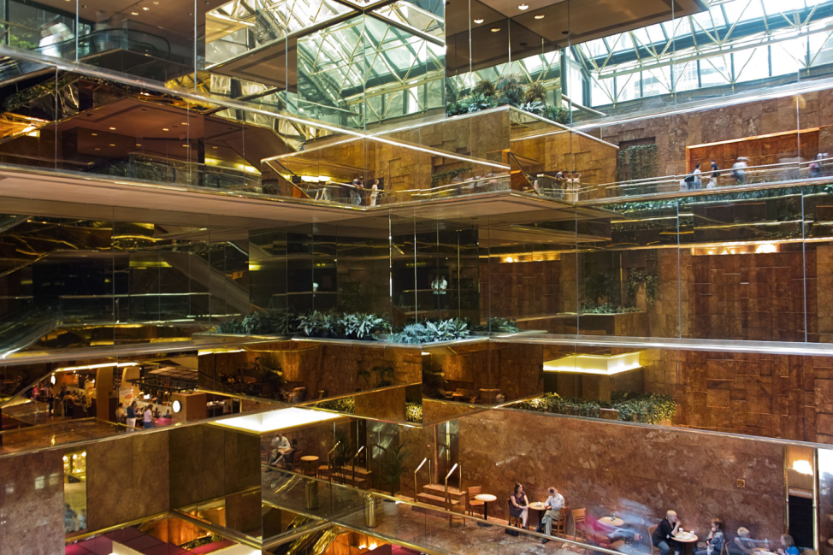
Figure 17 Trump Tower, New York City
One project for the future of my site has already been announced. The owners of Copley Place want to build an extension to Niemen Marcus and a tall residential tower on one corner of Copley Place. This would enclose the courtyard currently on the site to create a “winter garden” space. On top of this winter garden about 40 floors of residential units would be built. This tower would bring even more people back into the city. The people who could afford such high-rise apartments would likely work in the nearby office buildings of Copley Place and the Prudential Center. This would help lower the demand on the transportation systems, both road and mass transit, by giving a few hundred residents a very short commute time. It would also contribute to the businesses that make the Back Bay livable – like the Shaw’s market and Trader Joes. It might even help swing the retail of Copley Place more towards everyday shops, as opposed to the luxury shops which exist today. This corner of the site originally had housing. The return of housing would indicate a full circle return to the original use of the site. In addition, the wealthy are returning to live in cities, a full circle return from the suburbs.
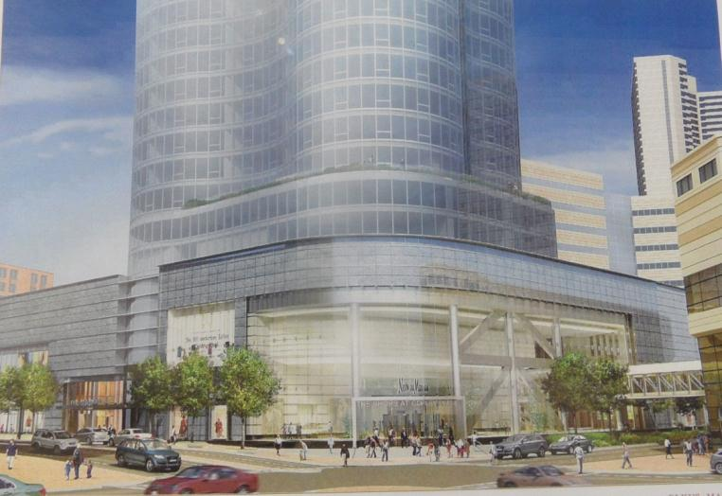
Figure 18 Proposed Copley Place Residential Tower from EIS
The buildings on my site reflect the attitudes from when they were built. We can still see many of these choices as traces and artifacts from when these particular ideas were popular.
For instance, early development was done in the form of small, individually built buildings built by different developers over time. The 1960s brought an era of large-scale urban planning where traditional streets were replaced with mega-projects with internal circulation mechanisms and attention to logistical requirements like parking. In the more recent years, large projects are still being built. However, large projects are trying to look smaller, with features that were once shunned, such as city streets and low-rise development. Through books such as The Death and Life of Great American Cities, urban planners have realized that some elements discarded in the mega projects actually play an important role in creating safe, livable areas. Development school of thought has come full circle as people realize that dense, walkable cites with livable streets, are actually better than living in the suburbs, driving in, and walking through private, internal walkways to everything they need for the day.
On the other hand, some things have not come full circle yet. However, my site will continue to change and update, bringing new fashions of urban development to the area. Some of these developments might go full circle back to how the site or the city was originally built.

Revised 5/7/2011
Jacobs, Jane. The Death and Life of Great American Cities. New York: Random House, 1993.
Produced in Google Earth, Google.
Plasmeier, Michael. Copley Place: Site Through Time. 23 April 2011. http://minisites.theplaz.com/4.211/site-through-time
United States. Department of Transportation. Urban Mass Transportation Administration. Draft Environmental Impact Statement: Orange Line Relocation and Arterial Street Construction South Cover to Forest Hills, Boston Massachusetts. Volume 1. 1977.
Copley Place Expansion Project. CAC Meeting #9. Wednesday, November 19, 2008 Location: Copley Place – 4th Floor Office Level http://www.bostonredevelopmentauthority.org/pdf/PlanningPublications/Copley%20Place%20CAC%20Meeting%209%20Notes%2011-19-08.pdf
See also http://money.cnn.com/2005/01/11/news/fortune500/retail_lifestylecenter/ and http://www.usatoday.com/news/nation/2008-01-03-downtownmalls_N.htm
See maps in assignment 3: Plasmeier, Michael. Copley Place: Site Through Time. 23 April 2011. http://minisites.theplaz.com/4.211/site-through-time
Shoup, Donald. “Who Should Pay for Parking?” CATO Unbound. 13 April 2011. Retrieved 2011-4-22. http://www.cato-unbound.org/2011/04/13/donald-shoup/who-should-pay-for-parking/
MIT Investment Management Company. Steve Marsh, Managing Director. PUD-5 Zoning Petition. Retrieved 2011-5-7. http://web.mit.edu/newsoffice/images/documents/zoning-petition.pdf
Wanderungen. “Trump Tower New York.” 2008 Aug 26. http://www.flickr.com/photos/wanderungen/2860293585/ CC BY-NC 2.0 Generic License http://creativecommons.org/licenses/by-nc/2.0/deed.en
Epsilon Associates. Copley Place Retail Expansion and Residential Addition. June 2008.
Jacobs, Jane. The Death and Life of Great American Cities. New York: Random House, 1993.

