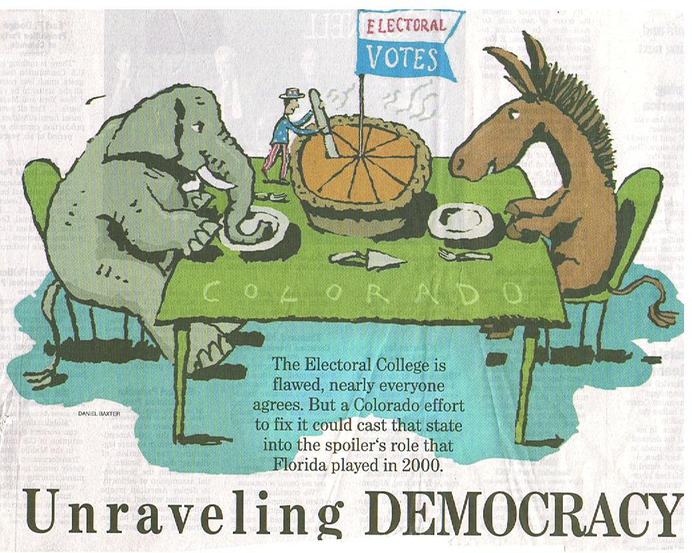
This statement shows that the Constitution wanted a better union between the states then the Articles of Confederation provided. It also wants to make our country better as is the theme throughout the Preamble. The Constitution was a fresh start for America, and they wanted it to turn for the best. Remember, no other country had ever attempted to do this.

We are always working on forming a ‘better’ country. We are always adding, changing, or getting rid of laws. However, people are always arguing on how to do exactly that. This article is debating on should the electoral college system stay or go. People want to make our country better, but different people have different opinions on how to do that.

